Kubernetes



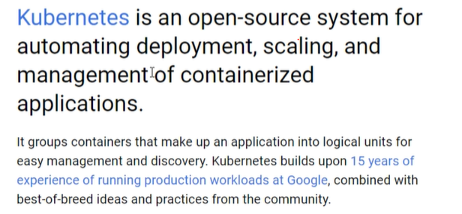<https://docs.docker.com/engine/swarm/>Swarm mode overview

*Estimated reading time: 3 minutes*

To use Docker in swarm mode, install Docker. See [installation instructions](https://docs.docker.com/install/) for all operating systems and platforms.

Current versions of Docker include *swarm mode* for natively managing a cluster of Docker Engines called a *swarm*. Use the Docker CLI to create a swarm, deploy application services to a swarm, and manage swarm behaviour.

Feature highlights

* **Cluster management integrated with Docker Engine:** Use the Docker Engine CLI to create a swarm of Docker Engines where you can deploy application services. You don’t need additional orchestration software to create or manage a swarm.
* **Decentralized design:** Instead of handling differentiation between node roles at deployment time, the Docker Engine handles any specialization at runtime. You can deploy both kinds of nodes, managers and workers, using the Docker Engine. This means you can build an entire swarm from a single disk image.
* **Declarative service model:** Docker Engine uses a declarative approach to let you define the desired state of the various services in your application stack. For example, you might describe an application comprised of a web front end service with message queueing services and a database backend.
* **Scaling:** For each service, you can declare the number of tasks you want to run. When you scale up or down, the swarm manager automatically adapts by adding or removing tasks to maintain the desired state.
* **Desired state reconciliation:** The swarm manager node constantly monitors the cluster state and reconciles any differences between the actual state and your expressed desired state. For example, if you set up a service to run 10 replicas of a container, and a worker machine hosting two of those replicas crashes, the manager creates two new replicas to replace the replicas that crashed. The swarm manager assigns the new replicas to workers that are running and available.
* **Multi-host networking:** You can specify an overlay network for your services. The swarm manager automatically assigns addresses to the containers on the overlay network when it initializes or updates the application.
* **Service discovery:** Swarm manager nodes assign each service in the swarm a unique DNS name and load balances running containers. You can query every container running in the swarm through a DNS server embedded in the swarm.
* **Load balancing:** You can expose the ports for services to an external load balancer. Internally, the swarm lets you specify how to distribute service containers between nodes.
* **Secure by default:** Each node in the swarm enforces TLS mutual authentication and encryption to secure communications between itself and all other nodes. You have the option to use self-signed root certificates or certificates from a custom root CA.
* **Rolling updates:** At rollout time you can apply service updates to nodes incrementally. The swarm manager lets you control the delay between service deployment to different sets of nodes. If anything goes wrong, you can roll back to a previous version of the service.

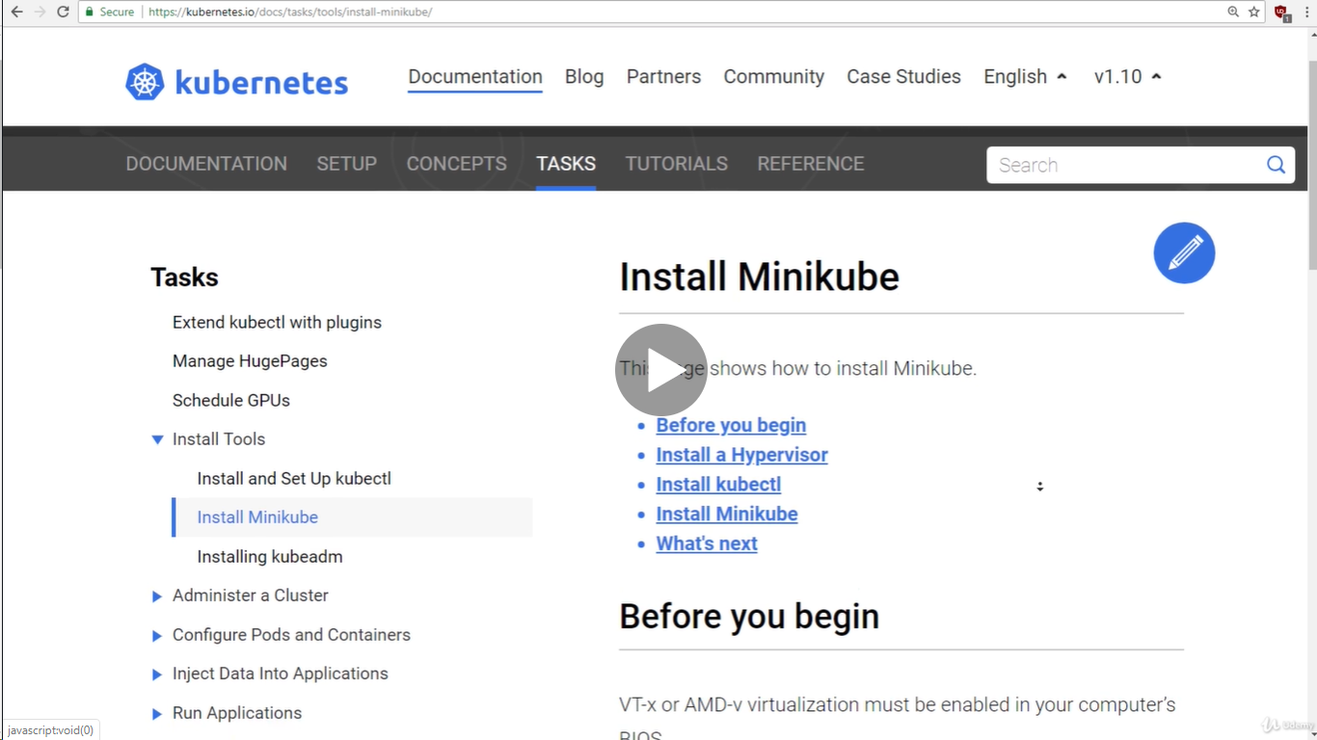

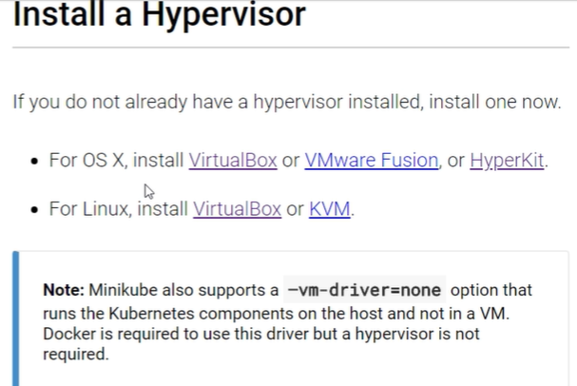

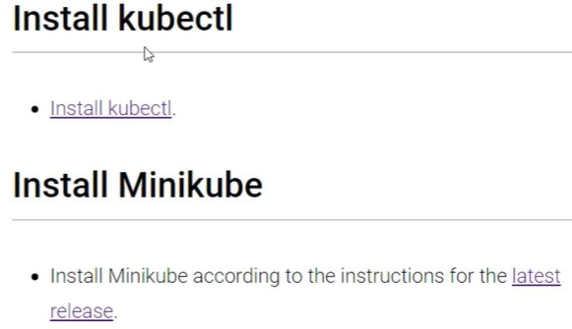

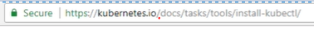

To download for the windows user below link.

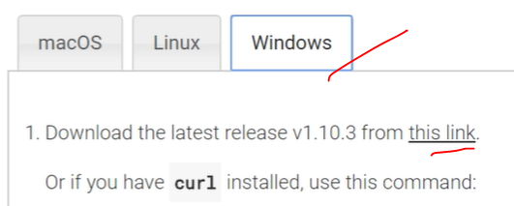

[www.sygwin.com](http://www.sygwin.com) is to user for the command line for the kubernetes.

Kubctl -will display the list of commands in the terminal.







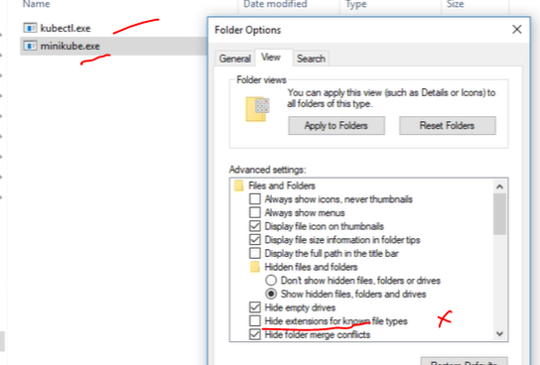

minikube –will list the help page.

Windows hyper visor command for the windows 10 users.



minikube start – starting the kubernetes virtual machine.

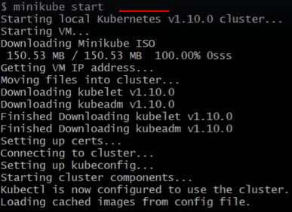

Kubectl version –it will list versions we are using..

If kubectl is not working or hanged state we need to trouble shoot the using below command.

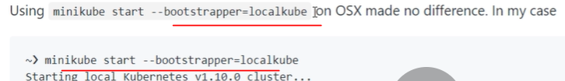

Minicube stop –it will stop the minicude

Minicube delete – it will the minicude from virtual machine.

Minikube start –it will start the minikube.

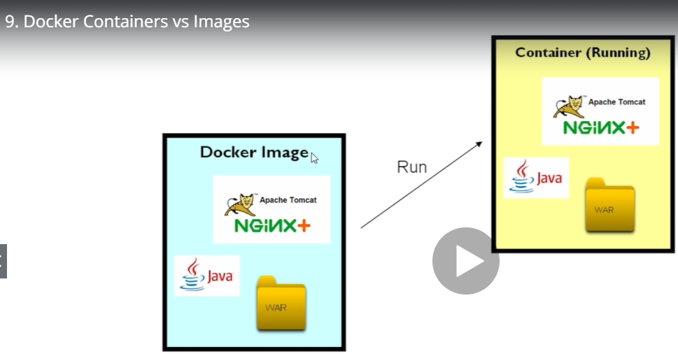

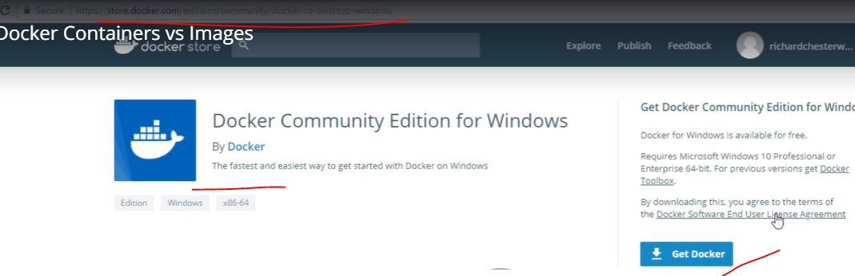

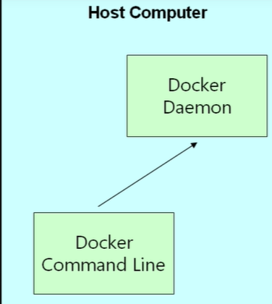

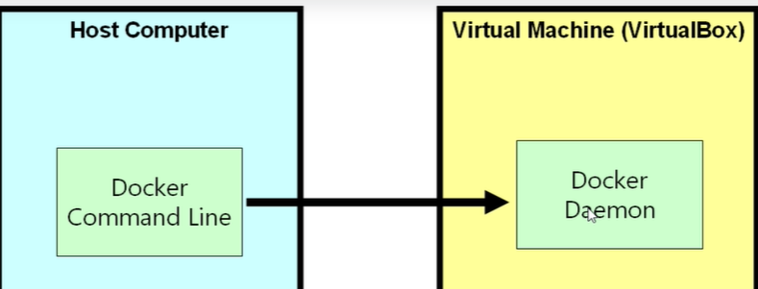

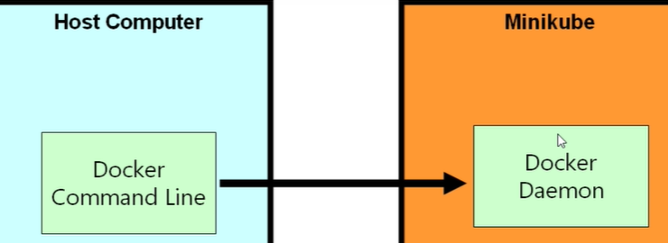

Docker image ls –it will list the list docket containers in the docker.

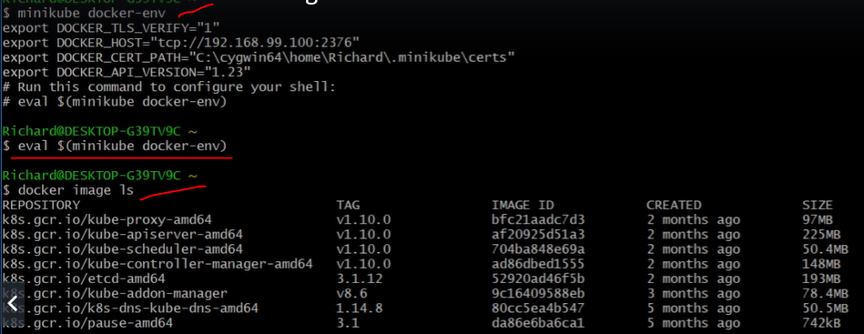





By using docker pull command will full the image from docker account..

Richardchesterwood is account k8s is a image name release is version image.

Docker image ls –it will list all of images..



**P** is page and **d** is background

Creating web page using docker images

docker container ls –it will list of kubernetes containers available in the docker.

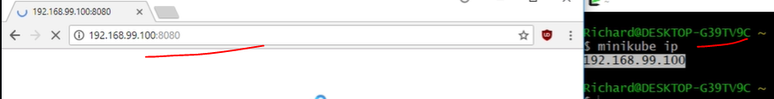

We need to run with ipaddress:8080 for the webpage.by using first 3 characters using we can stop and start the containers.

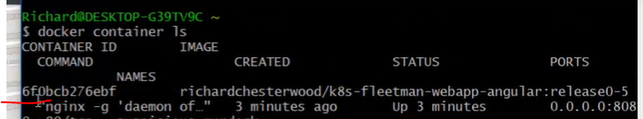 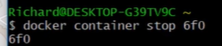

docker container rm 6fo –it will remove the container and web page also won’t be working.

<https://kubernetes.io/docs/concepts/workloads/pods/pod/>

## What is a Pod?

A Pod (as in a pod of whales or pea pod) is a group of one or more [containers](https://kubernetes.io/docs/concepts/overview/what-is-kubernetes/#why-containers) (such as Docker containers), with shared storage/network, and a specification for how to run the containers. A Pod’s contents are always co-located and co-scheduled, and run in a shared context. A Pod models an application-specific “logical host” - it contains one or more application containers which are relatively tightly coupled — in a pre-container world, being executed on the same physical or virtual machine would mean being executed on the same logical host.

While Kubernetes supports more container runtimes than just Docker, Docker is the most commonly known runtime, and it helps to describe Pods in Docker terms.

The shared context of a Pod is a set of Linux namespaces, cgroups, and potentially other facets of isolation - the same things that isolate a Docker container. Within a Pod’s context, the individual applications may have further sub-isolations applied.

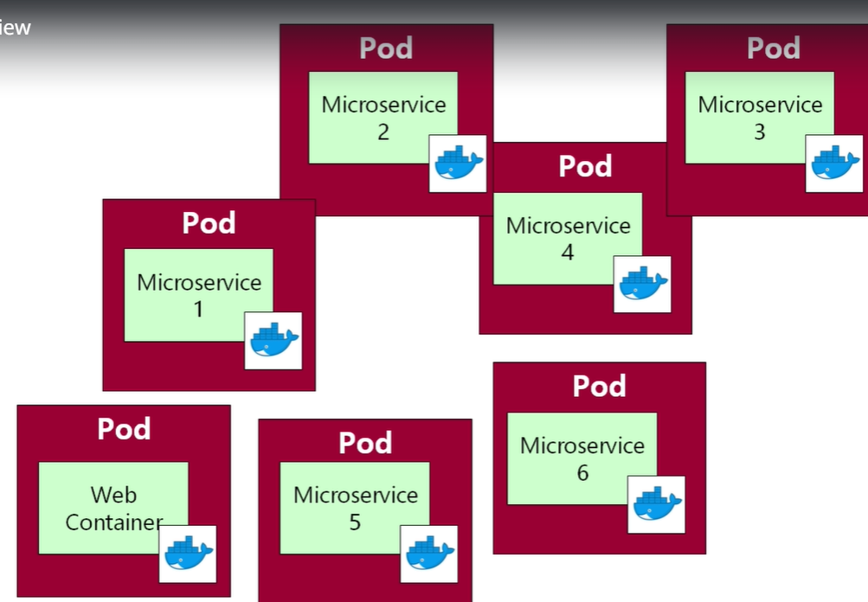

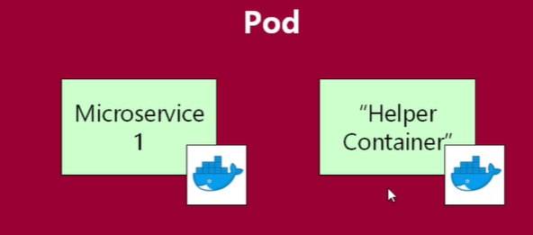

in Docker Hub

## Alternatives considered

Why not just run multiple programs in a single (Docker) container?

1. Transparency. Making the containers within the Pod visible to the infrastructure enables the infrastructure to provide services to those containers, such as process management and resource monitoring. This facilitates a number of conveniences for users.
2. Decoupling software dependencies. The individual containers may be versioned, rebuilt and redeployed independently. Kubernetes may even support live updates of individual containers someday.
3. Ease of use. Users don’t need to run their own process managers, worry about signal and exit-code propagation, etc.
4. Efficiency. Because the infrastructure takes on more responsibility, containers can be lighter weight.

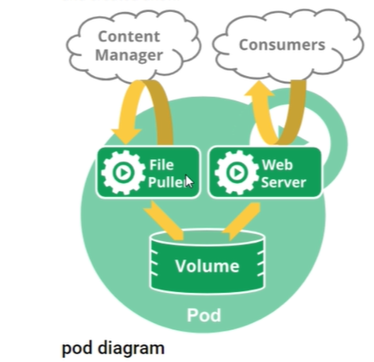

<https://kubernetes.io/docs/concepts/overview/kubernetes-api/>

<https://kubernetes.io/docs/reference/generated/kubernetes-api/v1.17/#pod-v1-core>

check the kubernetes page will lot of information and lot of mudules.

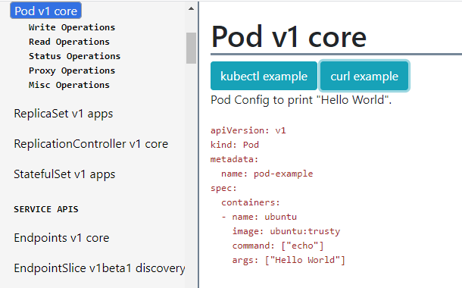

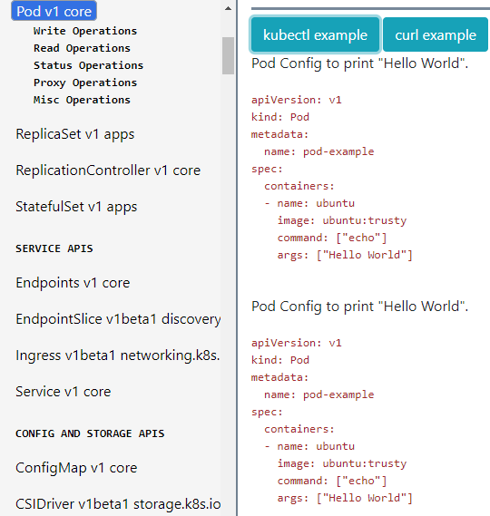

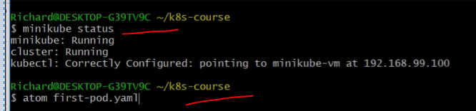

Checking the minikube status running or not then we are creating the **first.prod.yaml** file .

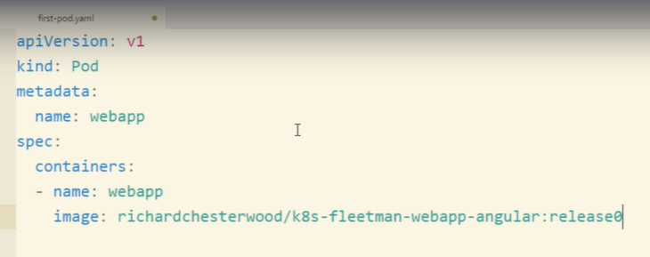

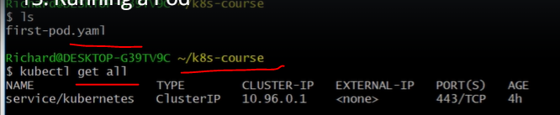

Kubectl get all command will find we have defined in the kubernetes cluster.

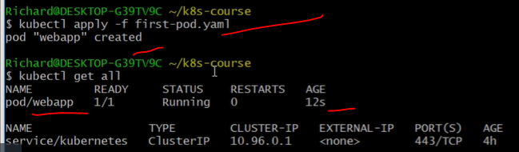

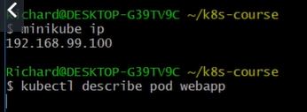

It will give you about the webapp information.

Kubectl exec webapp ls ==it will list directories in the webapp.

Kubectl -it exec webapp sh==it will open the sh terminall to run any commands **-it** is interactive mode.

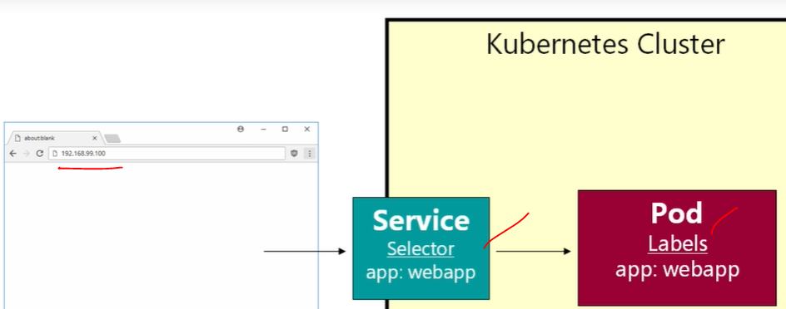

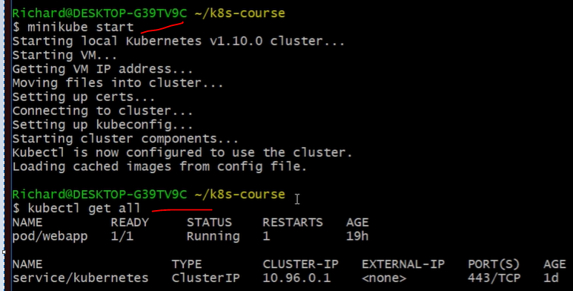

Kubectl get all == will get all running contains in the kubernetes.

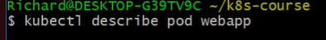create service for the prod.

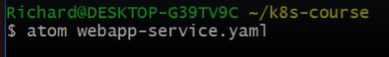

<https://kubernetes.io/docs/reference/generated/kubernetes-api/v1.17/#service-v1-core>

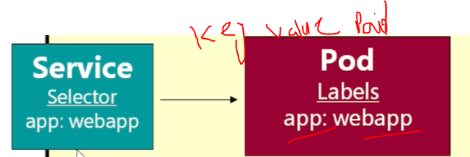

In the Kebernetes portal- [Service v1 core](https://kubernetes.io/docs/reference/generated/kubernetes-api/v1.17/#service-v1-core) example:

<https://kubernetes.io/docs/reference/generated/kubernetes-api/v1.17/#service-v1-core>

Service Config to load balance traffic across all Pods with the app=nginx label. Receives on and sends to port 80. Exposes an externally accessible endpoint.

kind: Service

apiVersion: v1

metadata:

# Unique key of the Service instance

name: service-example

spec:

ports:

# Accept traffic sent to port 80

- name: http

port: 80

targetPort: 80

selector:

# Loadbalance traffic across Pods matching

# this label selector

app: nginx

# Create an HA proxy in the cloud provider

# with an External IP address - *Only supported

# by some cloud providers*

type: LoadBalancer

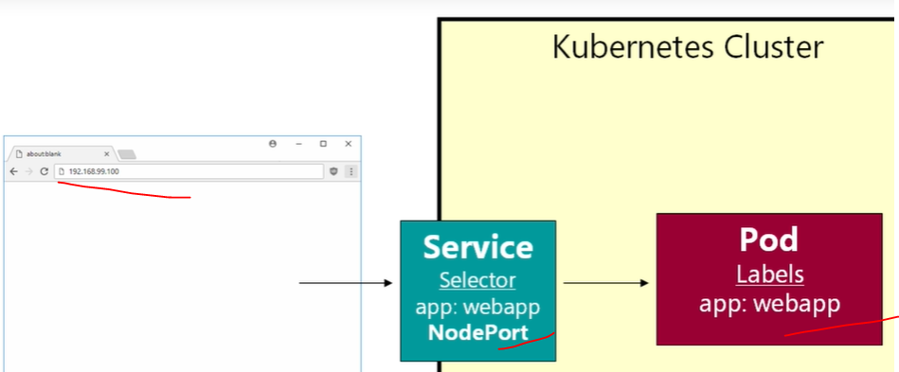

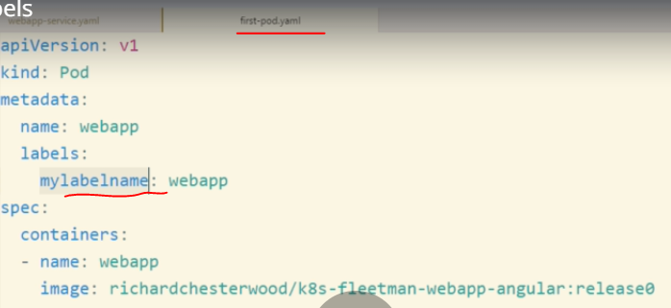

Using mylablename in the first-prod.yaml script running with below webapp-service.yaml script.

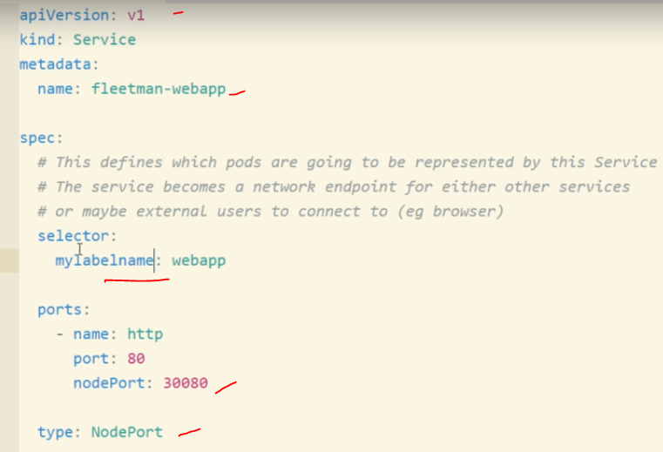

Running above webapp-service.yaml with below commands running both scripts commands to bring sites. Label should be match both scripts. Other wise site won’t be work.

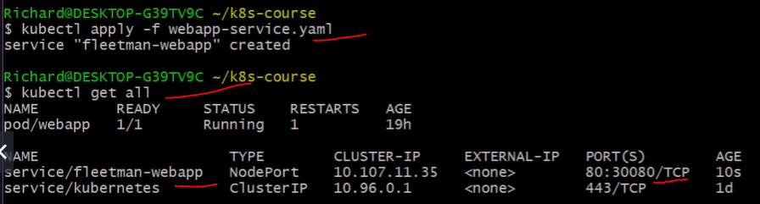

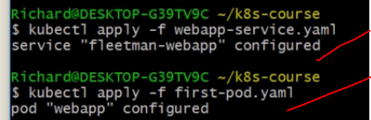

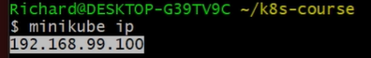

Checking web page running or not with **192.168.99.100:30080**

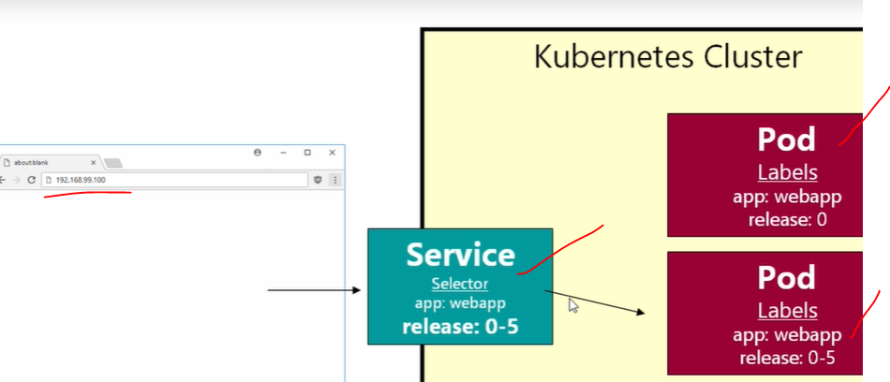

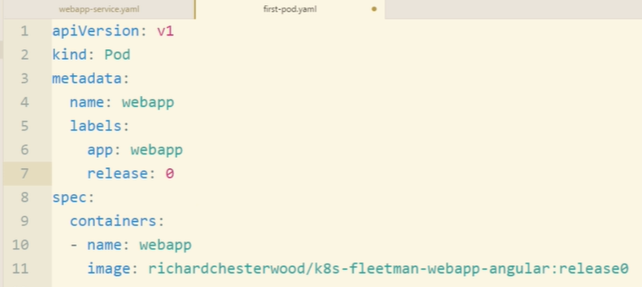

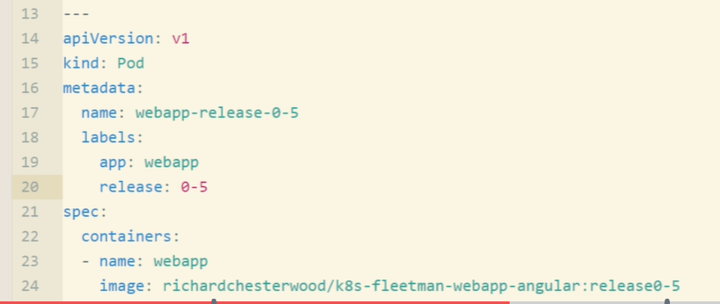

--- means add one more prod and running two prods at a time:

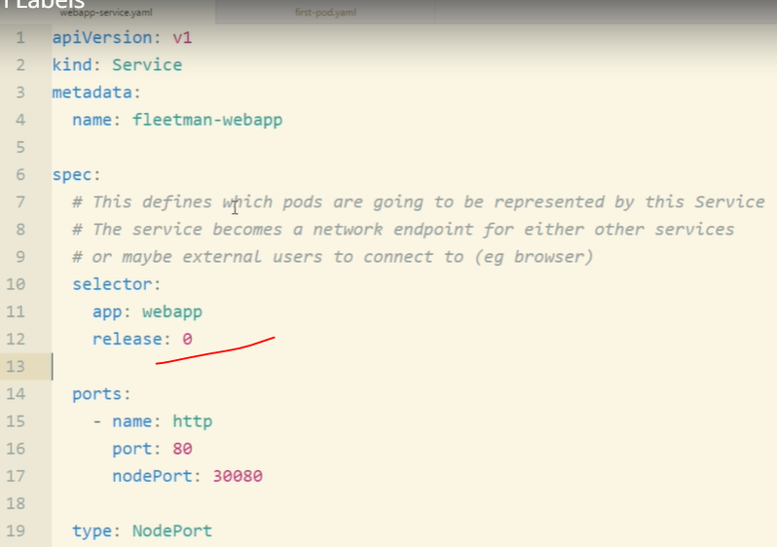

If we run the above script it will be fail need to add **“0” and release “0-5”** for zero release both scripts.

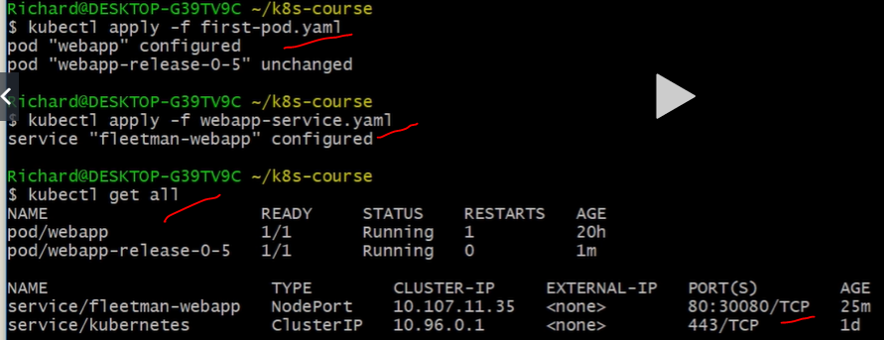

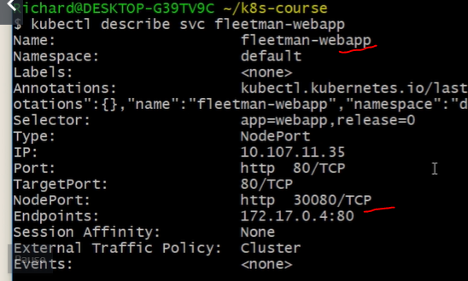

Run kubernetes prod command again:then check the web page again

Kubectl apply -f webapp-service.yaml

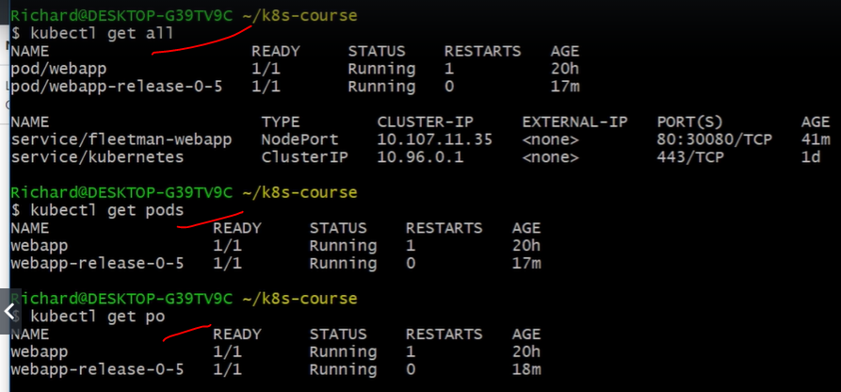

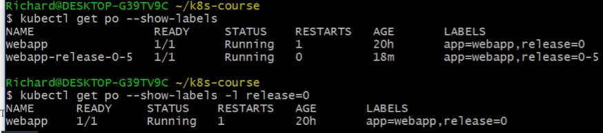

Filtering the running containers like release=0 or release=0-5 if you print wrong release name won’t be displayed anything.



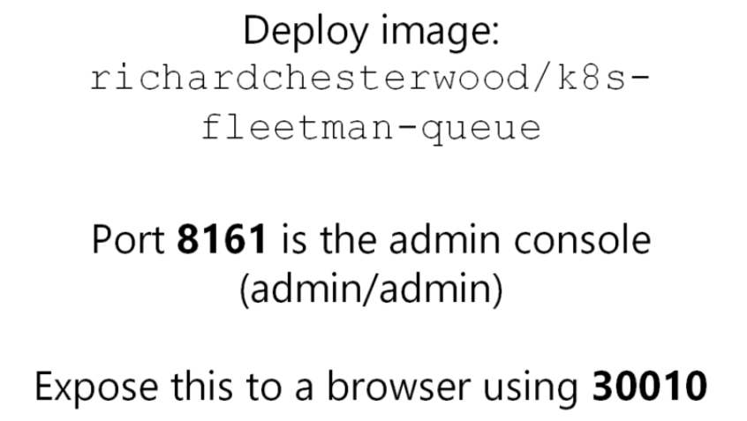

Minikube start==starting minibube

Kubectl get all==running containers

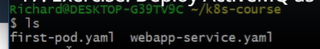

Mv first_prod.yaml **prod.yaml** renamed it and --- added one more prod for the deployment.

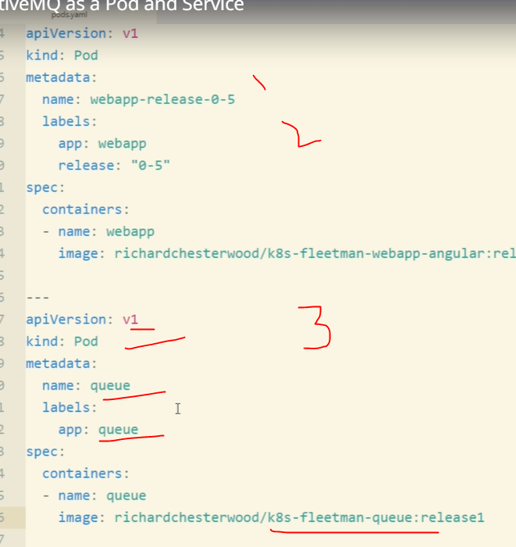

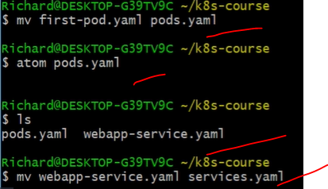

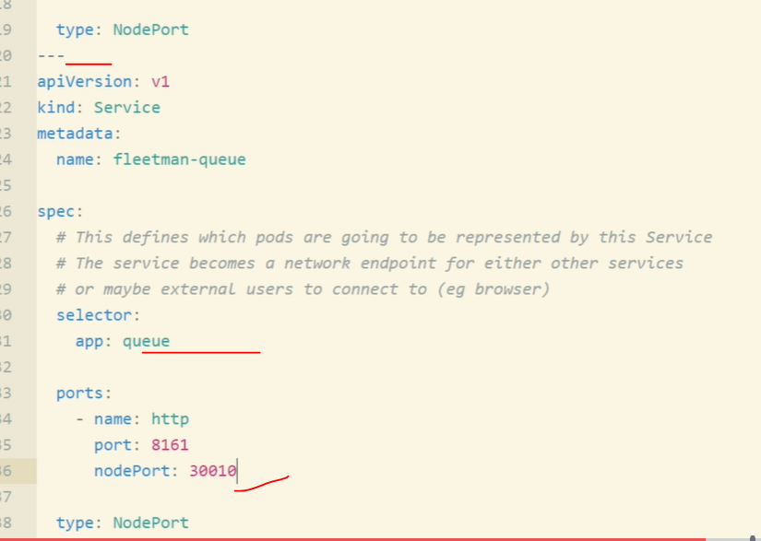

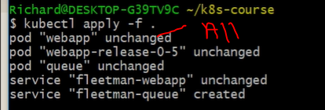

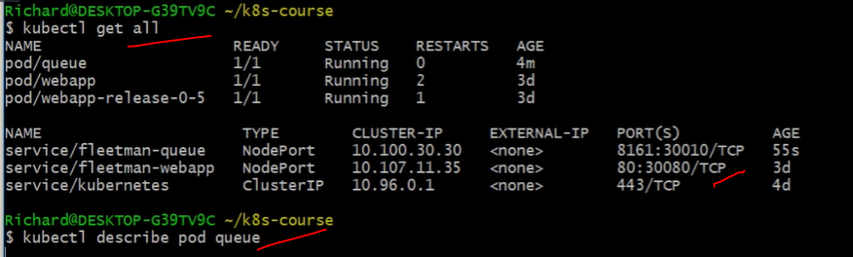o/p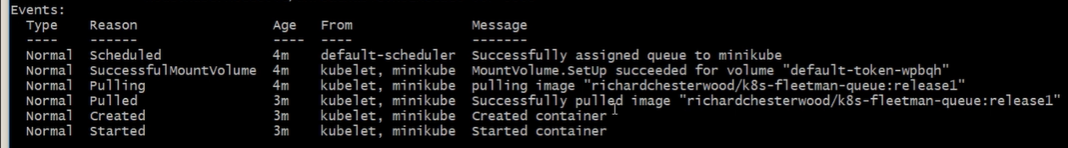

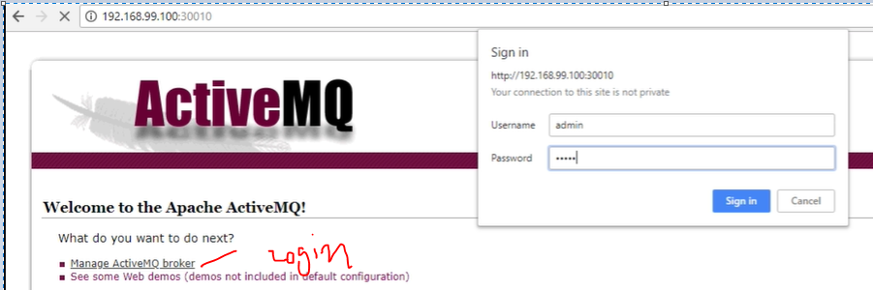

Replicasets:

Kubectl get all

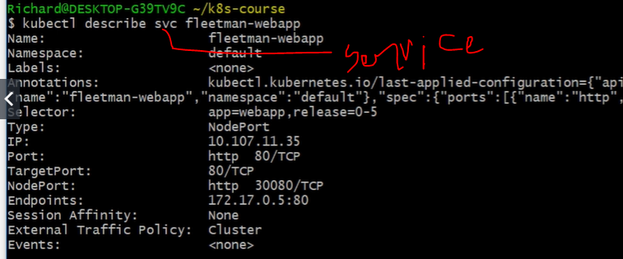

**Svc =service** delete command will gracefully **delete** the running containers.**po=prod and brosewwe also won’t be work.**

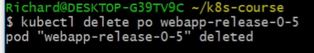

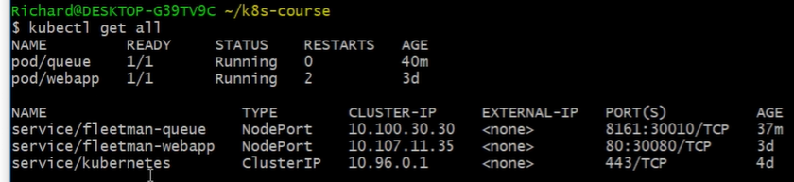

<https://kubernetes.io/docs/reference/generated/kubernetes-api/v1.17/#replicaset-v1-apps>

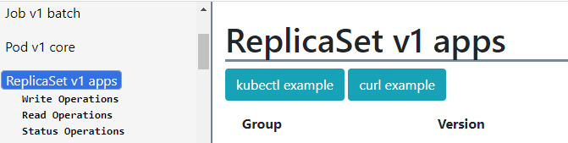

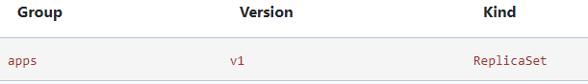

ReplicaSet Config to run 3 nginx instances. **Example**:

apiVersion: apps/v1

kind: ReplicaSet

metadata:

# Unique key of the ReplicaSet instance

name: replicaset-example

spec:

# 3 Pods should exist at all times.

replicas: 3

selector:

matchLabels:

app: nginx

template:

metadata:

labels:

app: nginx

spec:

containers:

# Run the nginx image

- name: nginx

image: nginx:1.10

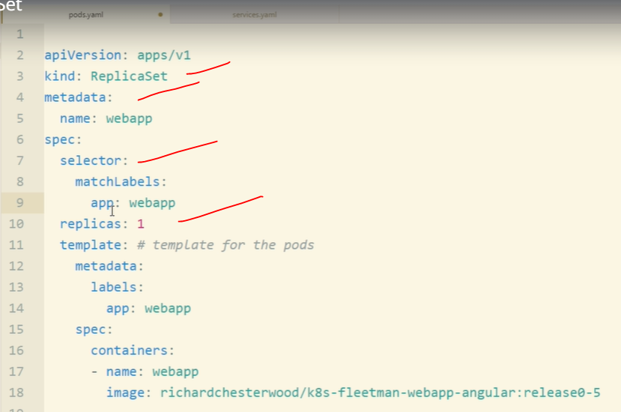

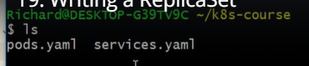

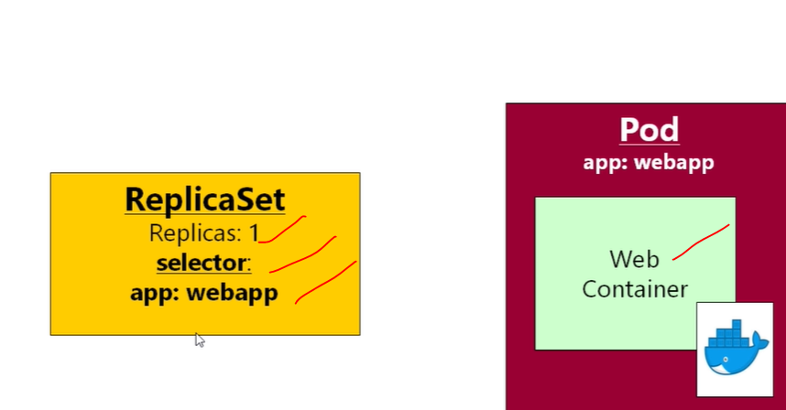

Kubectl get all

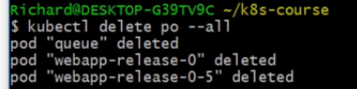

It’s going to delete all prods and services will be running on container.

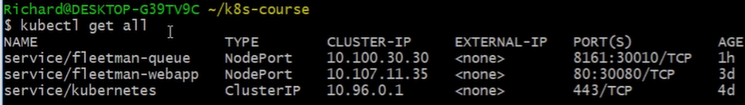

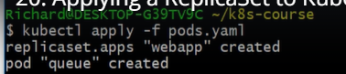

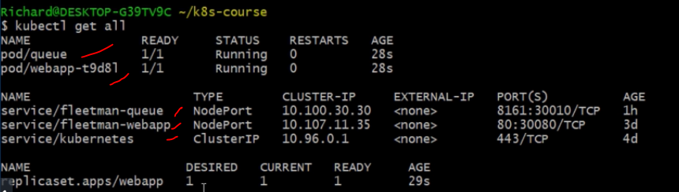

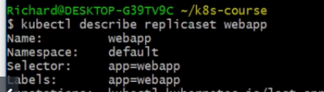

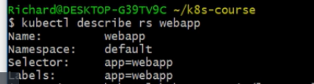

Rs=recurceivly 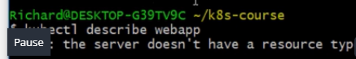

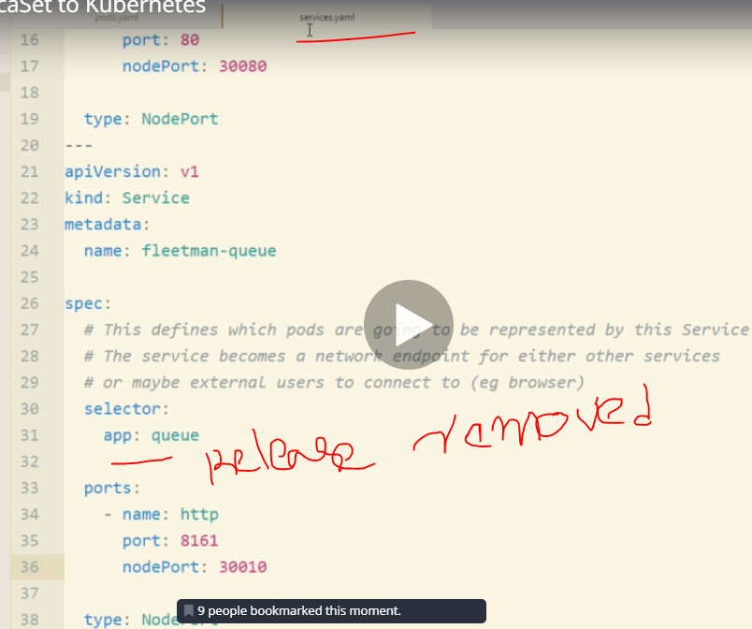

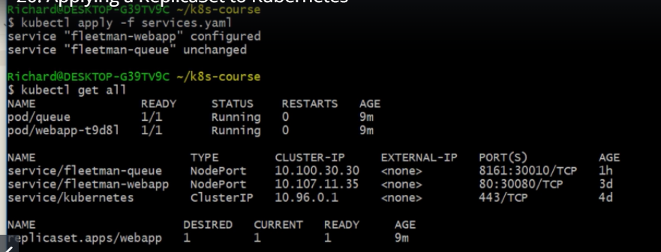

Check web page working or not now.

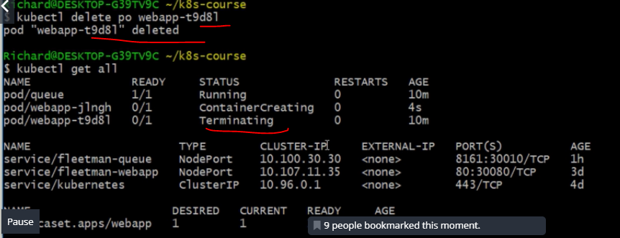

If main prod is down replica server will be up so our prod won’t be affected.

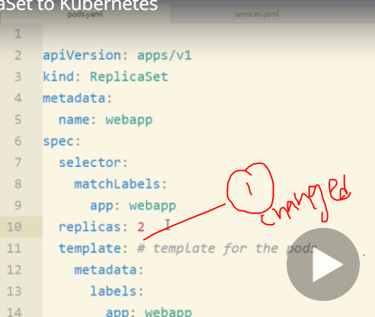

Run the below command each every time if thre is any change in our pord.yaml or service.yaml

Kubectl apply -f prods.yaml

Kubectl describe rs webapp

Kubectl get all

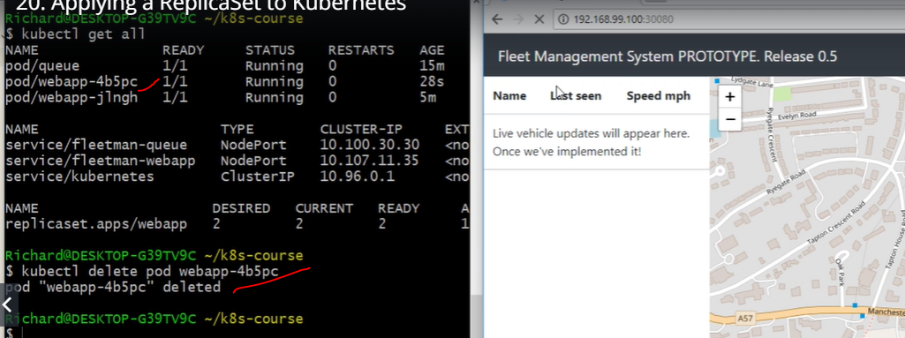

If we deleted webapp also our site won’t be down because of we have replicasets.

Deployments:

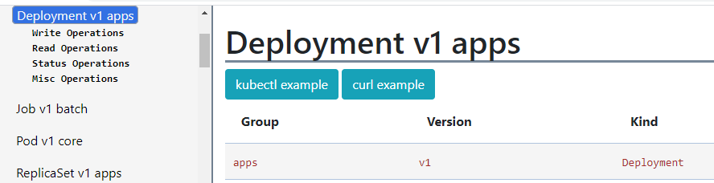

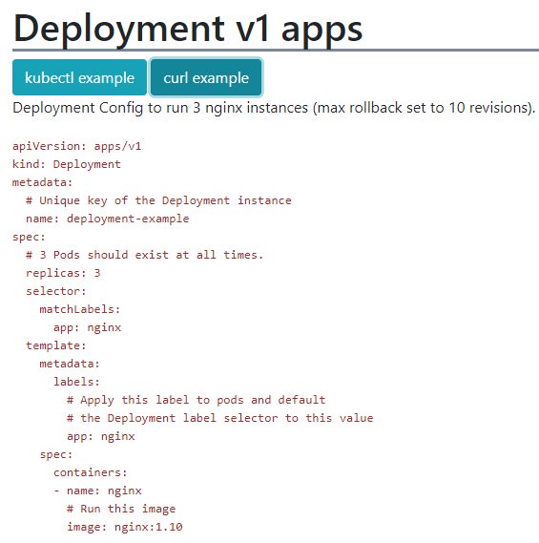

Kubectl get all

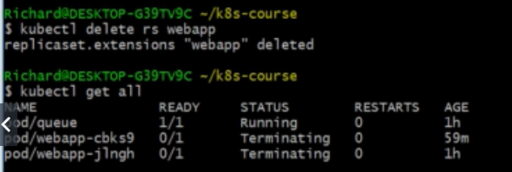

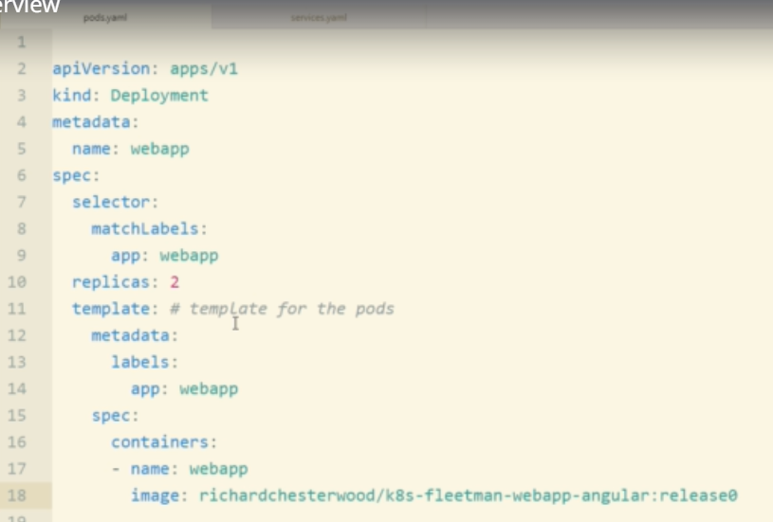

Run the below command each every time if thre is any change in our pord.yaml or service.yaml

Kubectl apply -f prods.yaml

Kubectl describe rs webapp

Kubectl get all

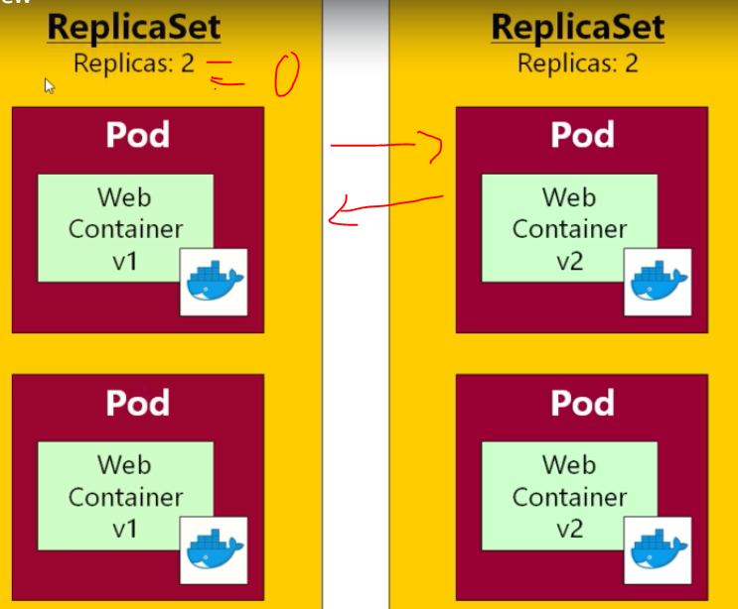

minReadyS: Minimum number of seconds for which a newly created pod should be ready without any of its container crashing, for it to be considered available. Defaults to 0 (pod will be considered available as soon as it is ready)

spec  
[*DeploymentSpec*](https://kubernetes.io/docs/reference/generated/kubernetes-api/v1.17/#deploymentspec-v1-apps)

<https://kubernetes.io/docs/reference/generated/kubernetes-api/v1.17/#deployment-v1-apps>

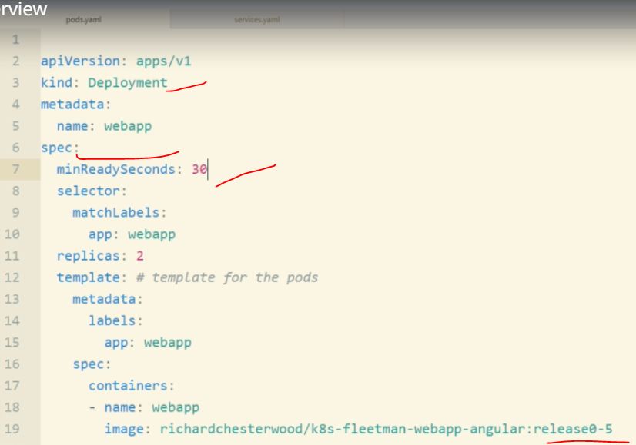

Run the below command each every time if thre is any change in our pord.yaml or service.yaml, finally check the webpage of our deployed webapp.

Kubectl apply -f prods.yaml

Kubectl describe rs webapp

Kubectl get all

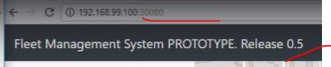

**DEPLOYMENT-ROLLOUT:**

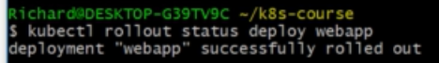

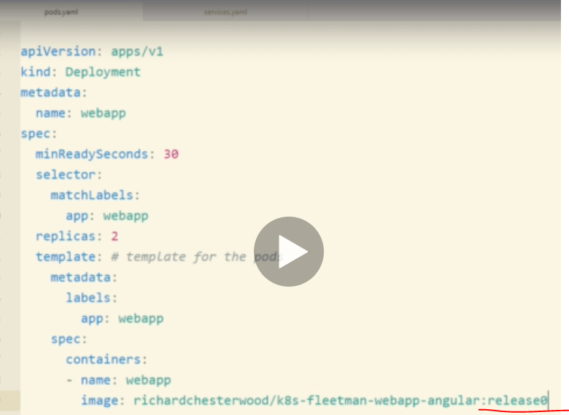

**After image name change**

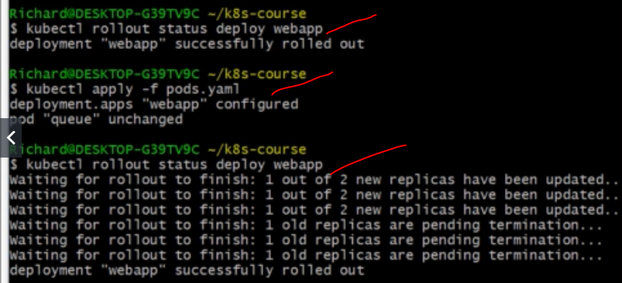

**The below command give previous rollout information:**

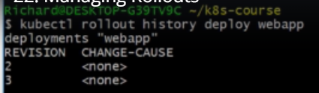

**If we want to roleback revision 2(undo before rolled back service.)**

**Kubectl rollout undo deploy webapp –to-revision-2**

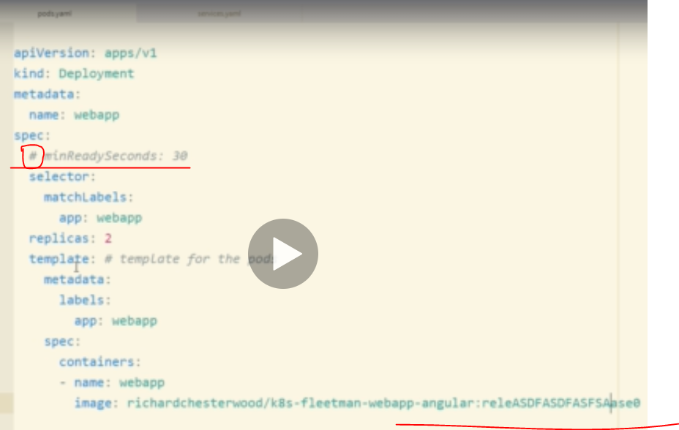

Run the below command each every time if thre is any change in our pord.yaml or service.yaml, finally check the webpage of our deployed webapp.

Kubectl apply -f prods.yaml

Kubectl describe rs webapp

Kubectl get all

**Again update image name=release0-5**

**And update the same.**



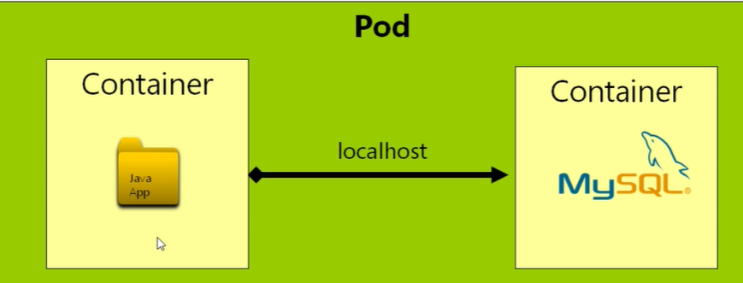

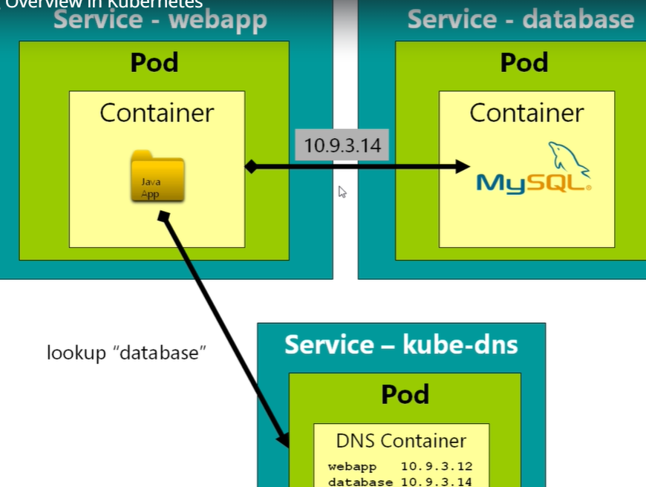

**Kubectl get all**

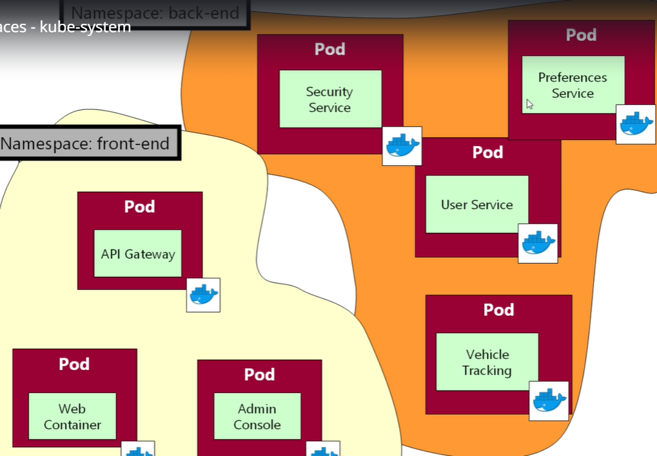

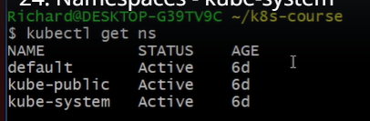**ns=name spaces**

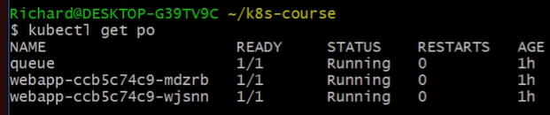

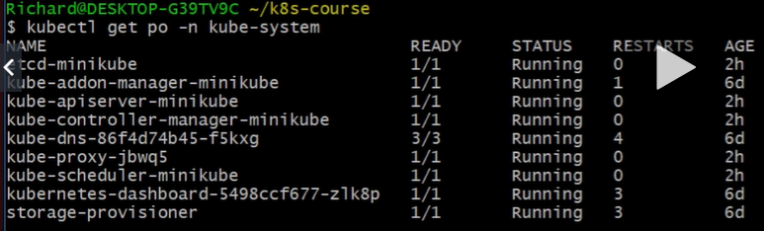

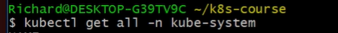

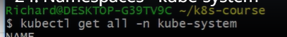

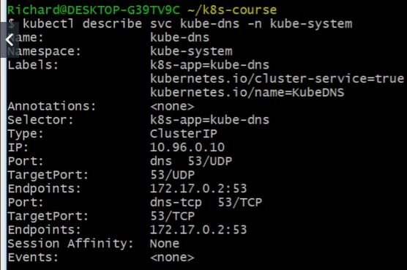

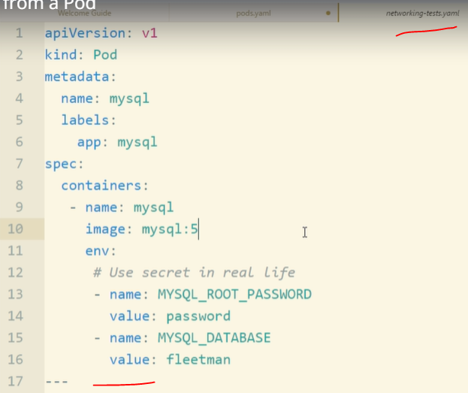

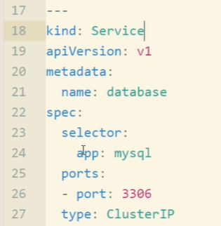

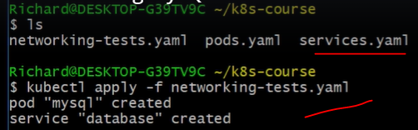

Run the below command each every time if thre is any change in our pord.yaml or service.yaml, finally check the webpage of our deployed webapp.

Kubectl apply -f prods.yaml

Kubectl describe rs webapp

Kubectl get all

**in github**

## [k8s-fleetman](https://github.com/madhureddy87/k8s-fleetman)/[k8s-fleetman-webapp-angular](https://github.com/madhureddy87/k8s-fleetman/tree/master/k8s-fleetman-webapp-angular)/****Dockerfile****

## 

## 

## By suing sh we can check Linux any commands in the webapp OS level. exit it.

## 

## 

## 

## 

## 

## 

## 

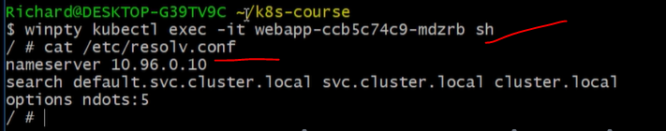

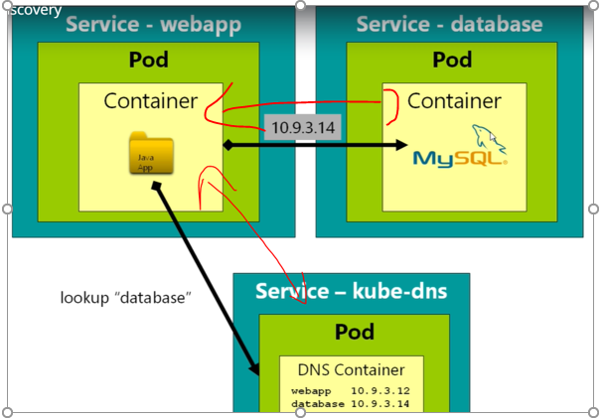

**The above command check the configuration between service-kube-dns to server-webapp,ipaddress, google.com connection and database connection information and we can install any kind of application using below.**

**Nslookup google.com**

**Nslookup database**

**apk update**

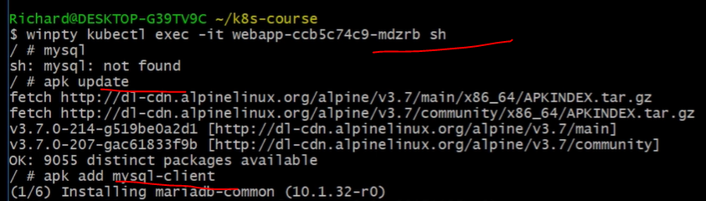

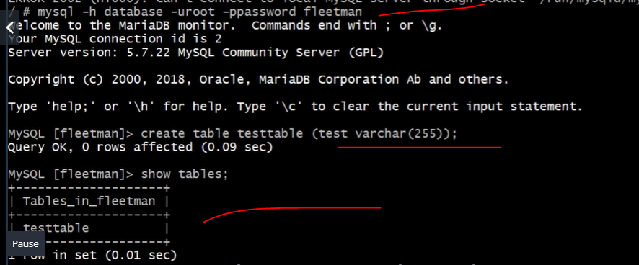

**Connect to the database and creating the tables using networking commands and creating connection using as like diagram.**

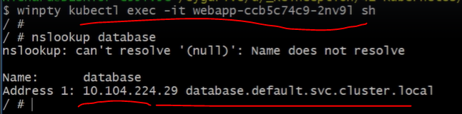

**I recommend before starting this section that you set up minikube with plenty of RAM. To do this:**

1. Stop minikube with "minikube stop"
2. Delete your existing minikube with "minikube delete"
3. Remove any config files with "rm ~/.kube" and "rm ~/.minikube". Or, delete these folders using your file explorer. The folders are stored in your home directory, which under windows will be "c:\Users\<your username>"
4. Now restart minikube with "minikube start --memory 4096".

This will allocate 4Gb of RAM to minikube (I'm assuming you have enough host ram to support this) and should give a much more comfortable experience in the next few



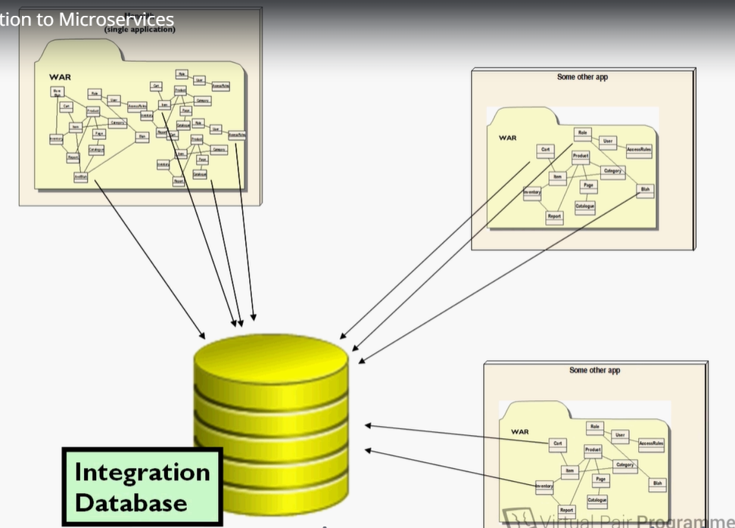

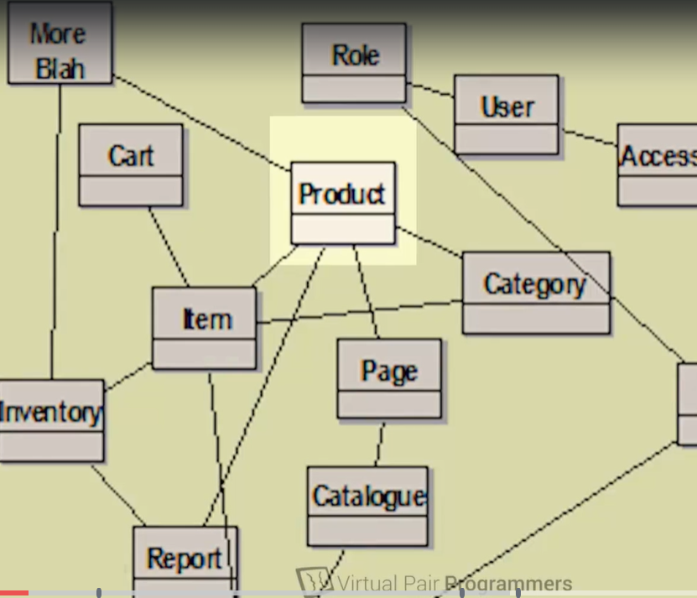

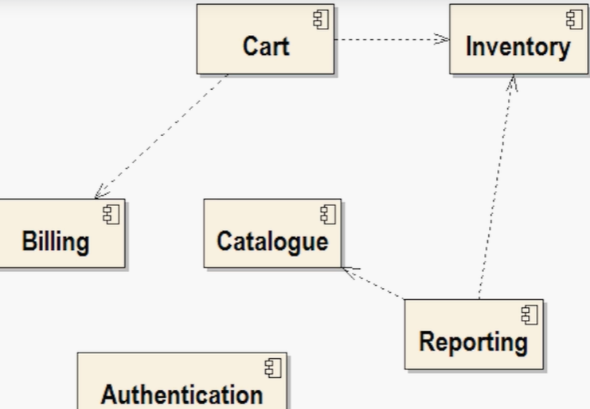





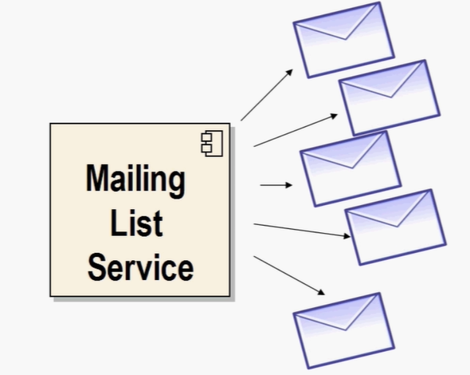

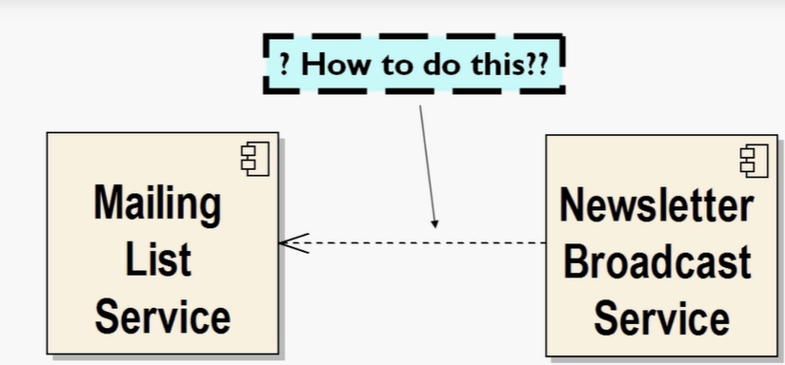

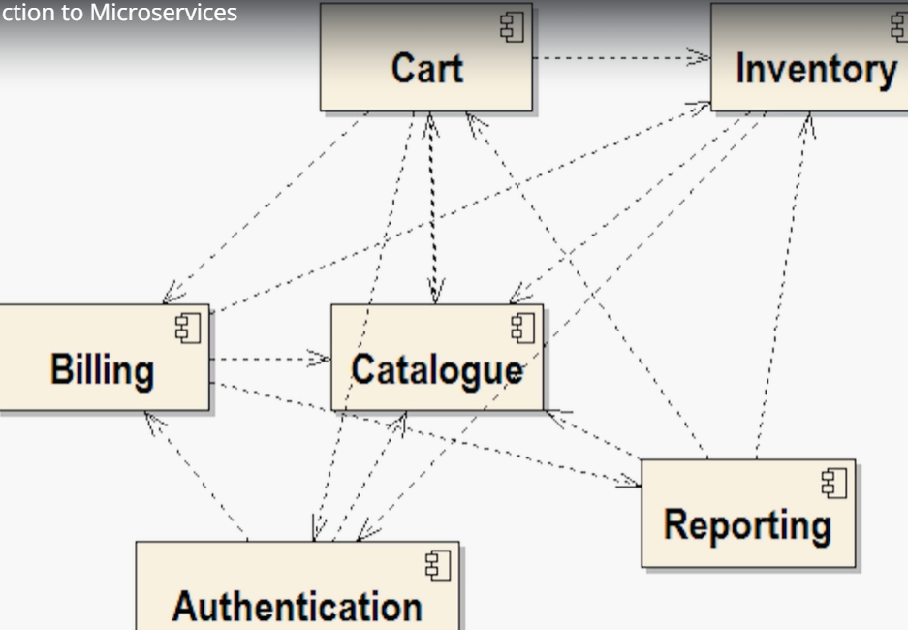

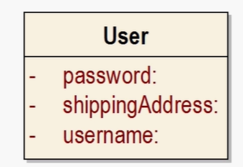

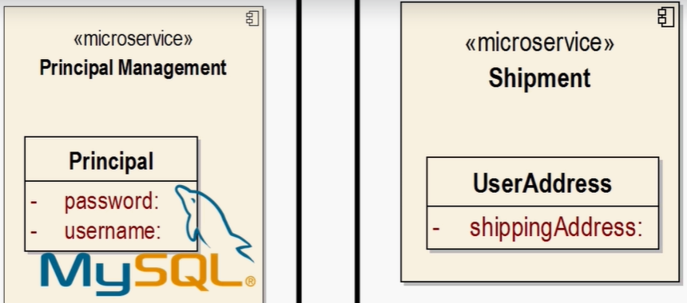

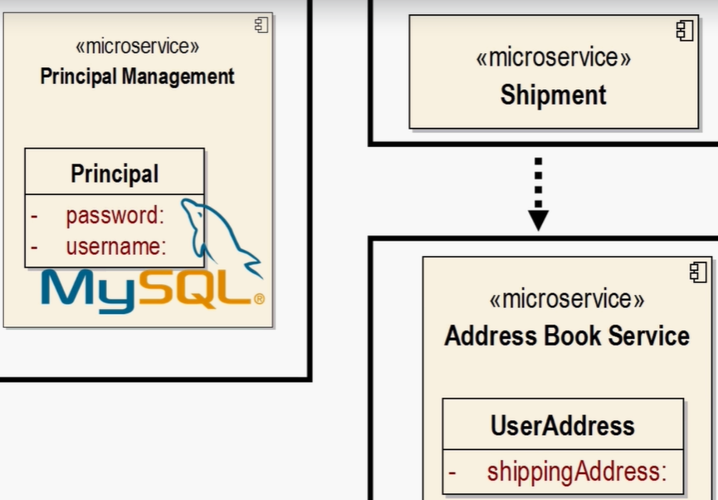

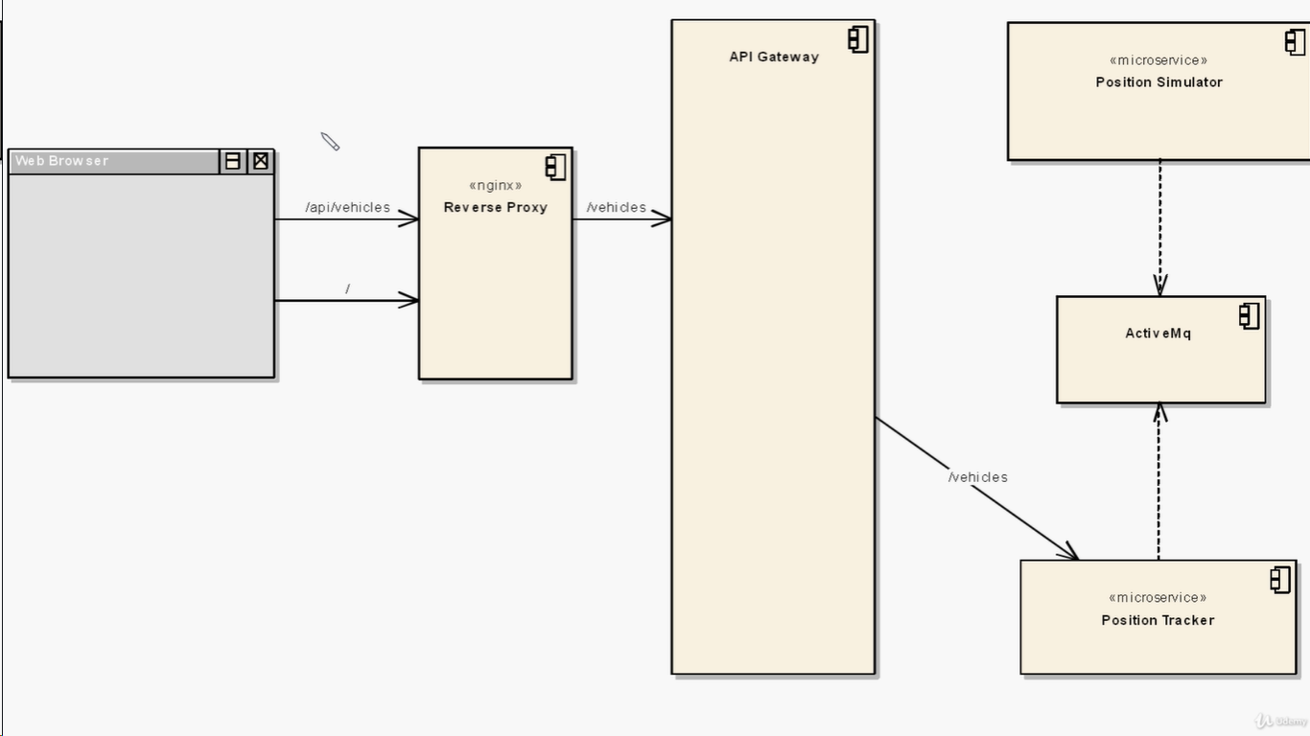

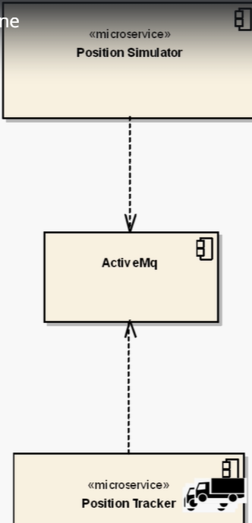



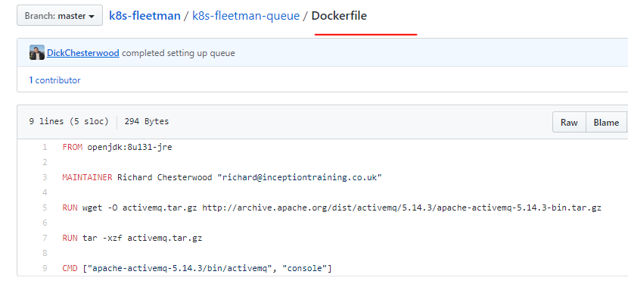

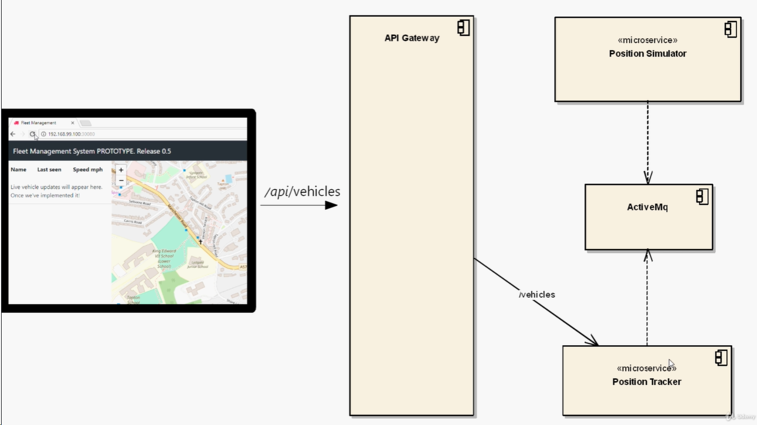

<https://microservices.io/patterns/apigateway.html>

# Pattern: API Gateway / Backends for Frontends

## Context

Let’s imagine you are building an online store that uses the [Microservice architecture pattern](https://microservices.io/patterns/microservices.html) and that you are implementing the product details page. You need to develop multiple versions of the product details user interface:

* HTML5/JavaScript-based UI for desktop and mobile browsers - HTML is generated by a server-side web application
* Native Android and iPhone clients - these clients interact with the server via REST APIs

In addition, the online store must expose product details via a REST API for use by 3rd party applications.

A product details UI can display a lot of information about a product. For example, the [Amazon.com](http://amazon.com/) details page for [POJOs in Action](http://www.amazon.com/POJOs-Action-Developing-Applications-Lightweight/dp/1932394583) displays:

* Basic information about the book such as title, author, price, etc.
* Your purchase history for the book
* Availability
* Buying options
* Other items that are frequently bought with this book
* Other items bought by customers who bought this book
* Customer reviews
* Sellers ranking
* …

Since the online store uses the Microservice architecture pattern the product details data is spread over multiple services. For example,

* Product Info Service - basic information about the product such as title, author
* Pricing Service - product price
* Order service - purchase history for product
* Inventory service - product availability
* Review service - customer reviews …

Consequently, the code that displays the product details needs to fetch information from all of these services.



Kubectl get all

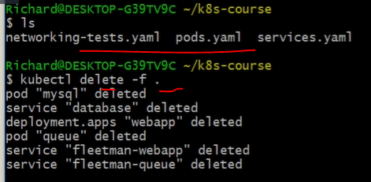

**It will delete all running prods in the docker.by default API kubernetes will be running on the container,if delete kubernetes automatically bring up kubernetes.**

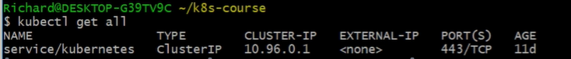

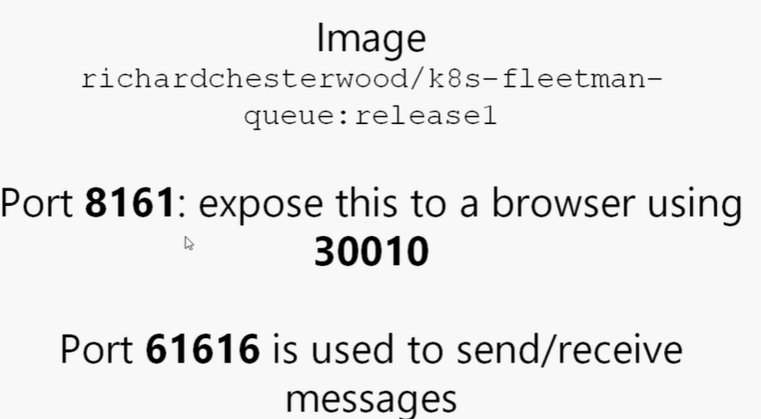

**Workloads.yaml file:**

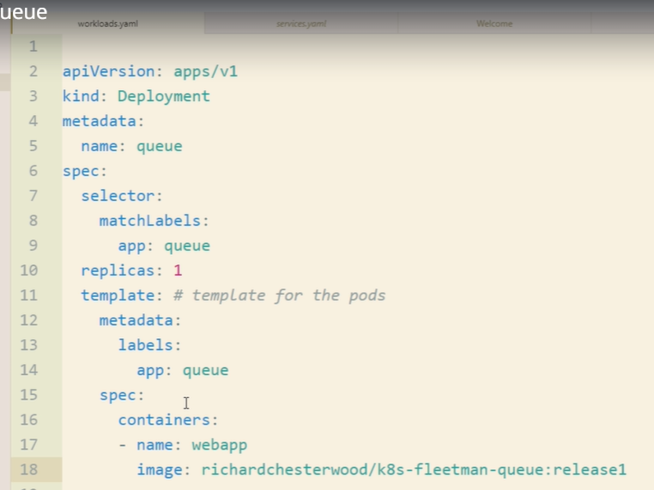

**Service.yaml files:**

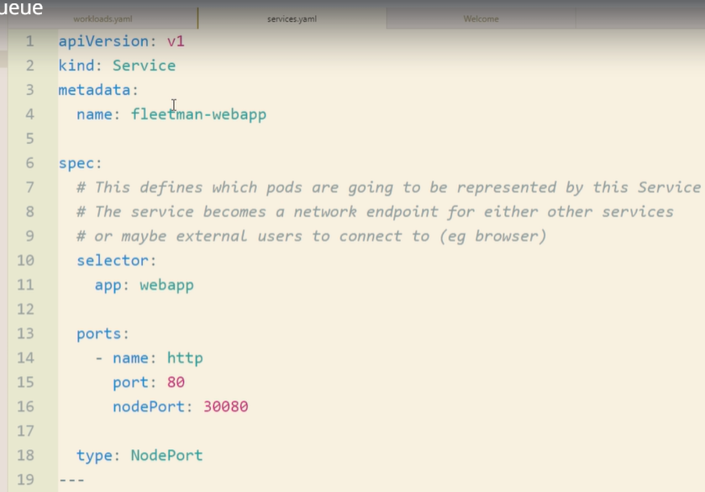

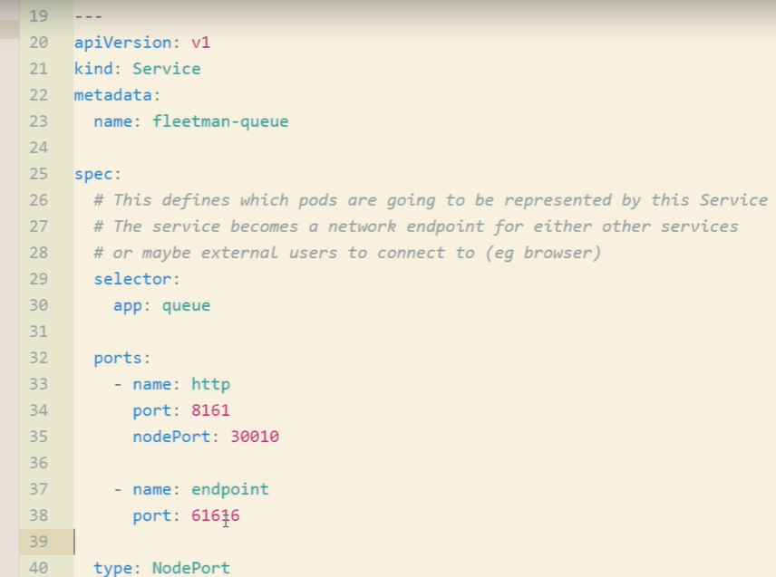

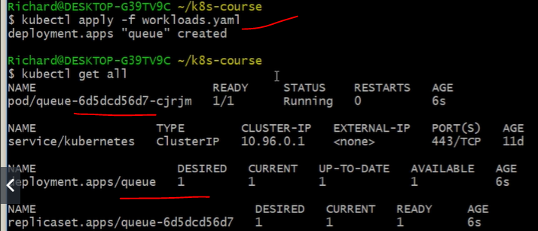

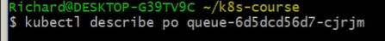

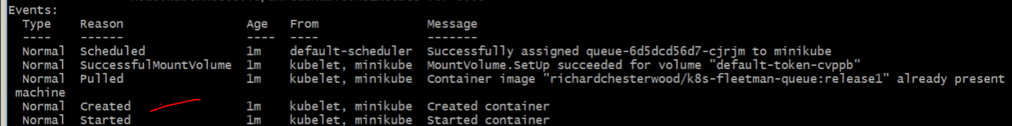

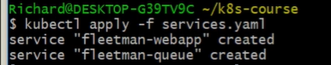

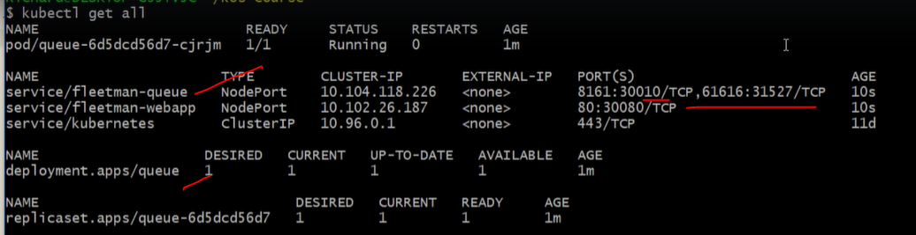

**Minikube ip**

**Login with ip and port number for web page.**

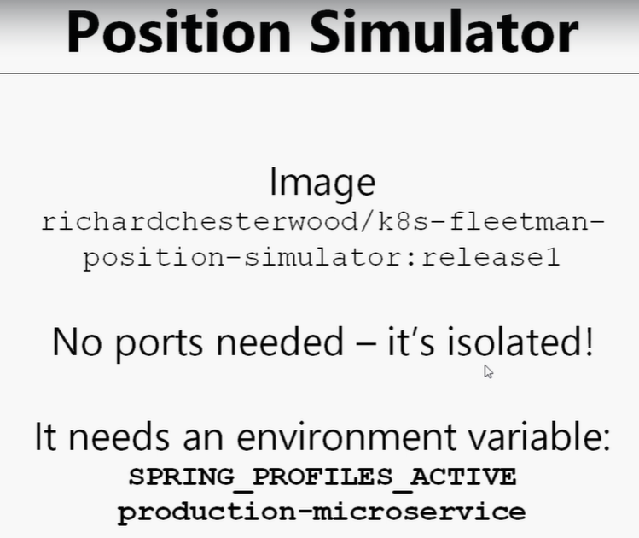

[k8s-fleetman](https://github.com/madhureddy87/k8s-fleetman)/**k8s-fleetman-position-simulator**/

**adding for the workloads.yaml one more simulator prod.**

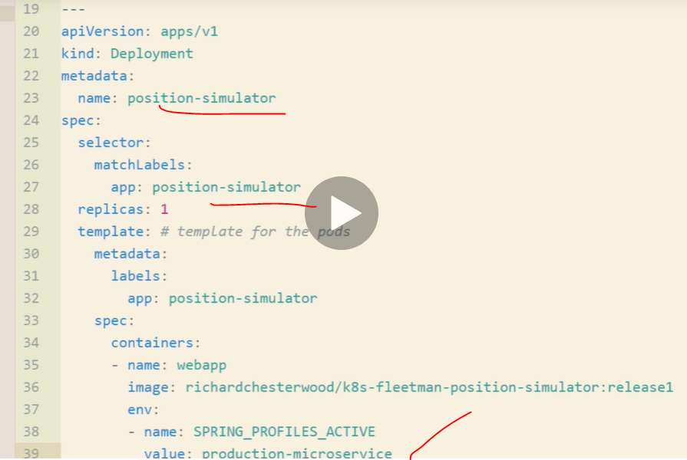

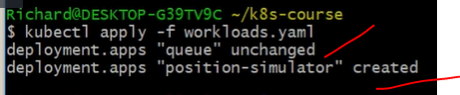

**Existed one “queue” unchanged and new created prod has been created successfully.**

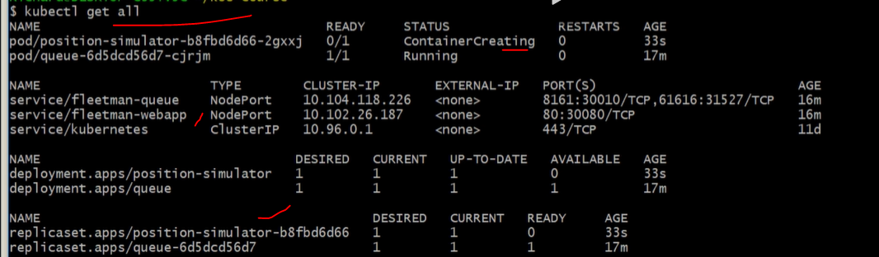

**To check particular prod logs:it will provide you full log information about the prod.both are same but -f full log.**





**Login webpage and check the message queue working or not.**

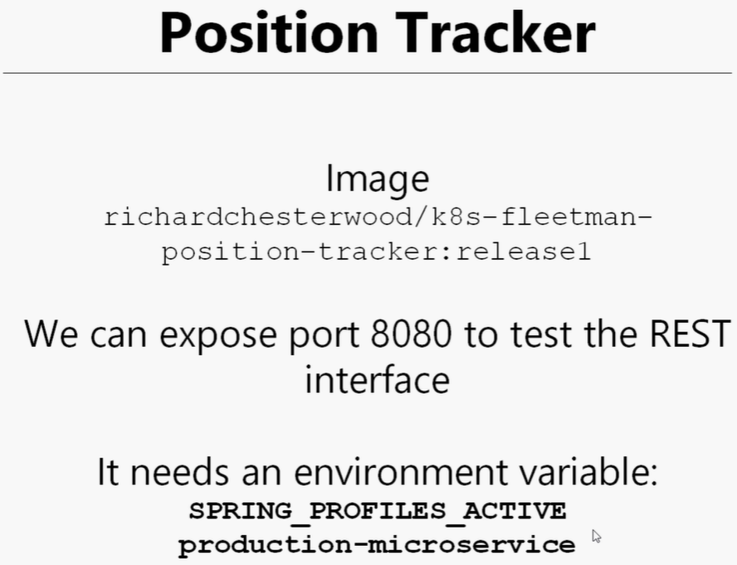

**Add one more prod in the workload.yaml file and run it.**

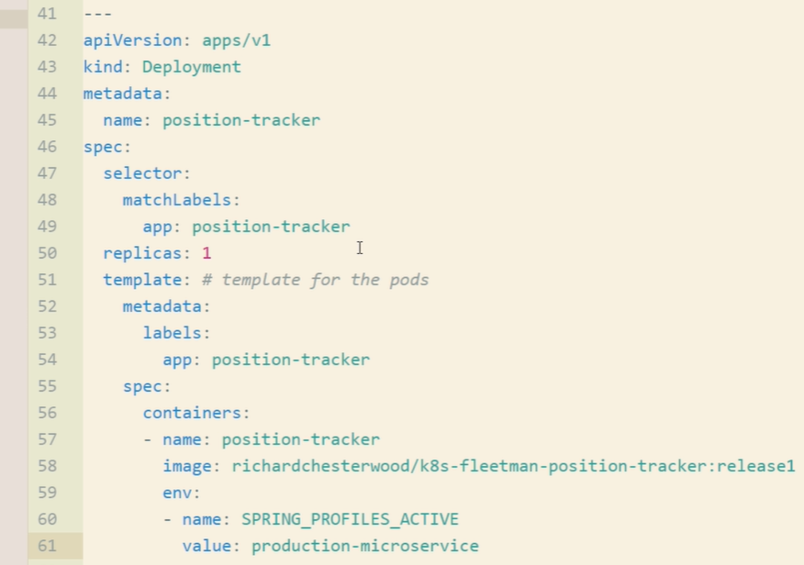

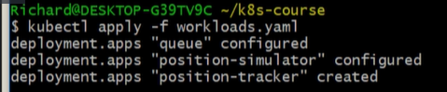

**Kubectl get all**



**Describe shows the container running status.**



After position-tracker deployed all messages are moved to prod.

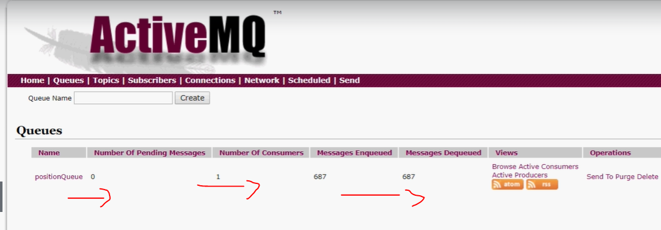

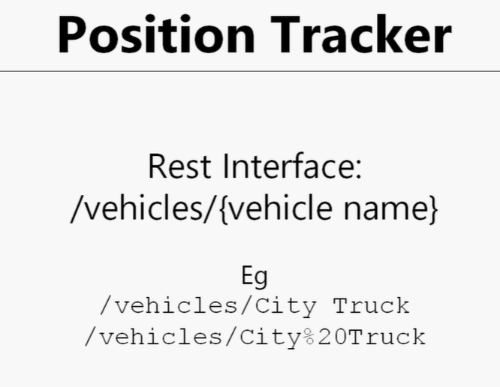

Adding one more service in services.yaml. file

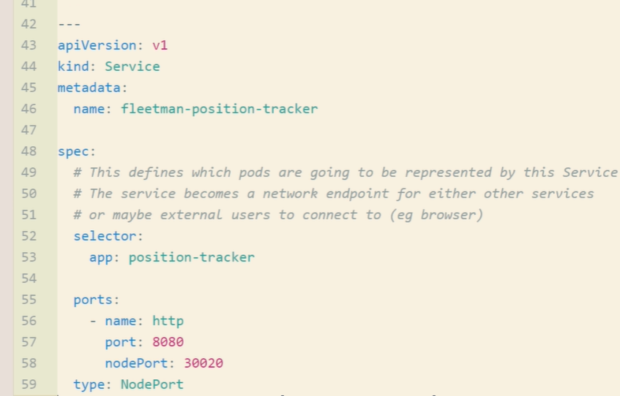

This will come error,we can remove nodeport then try it.

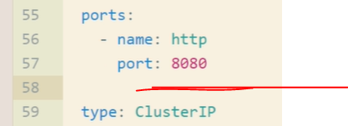

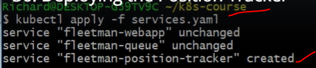

Kubectl get all

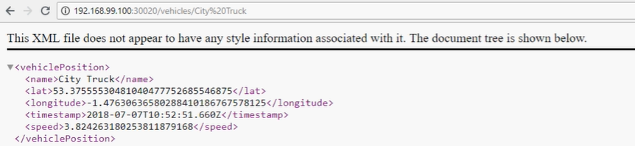

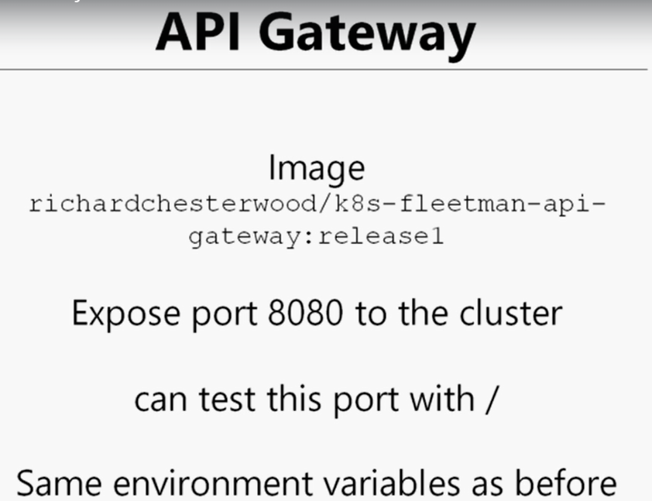

Add one more prod in the workloads.yaml file for the API gateway.

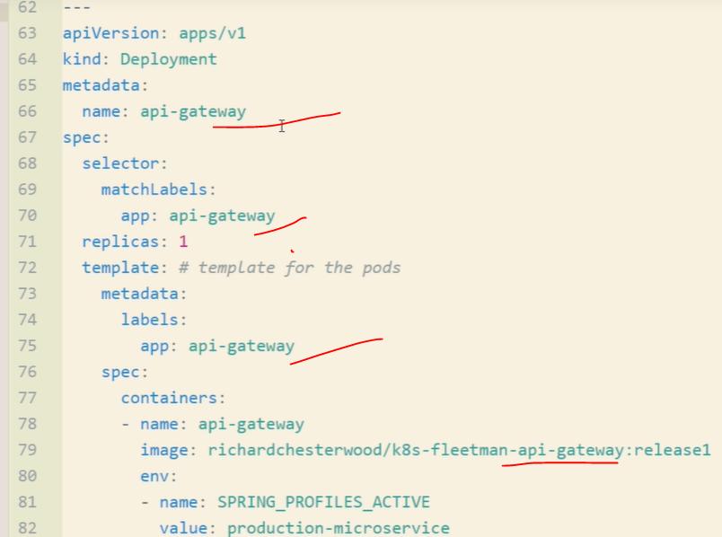

Add one more service in the services.yaml file for the API gateway.

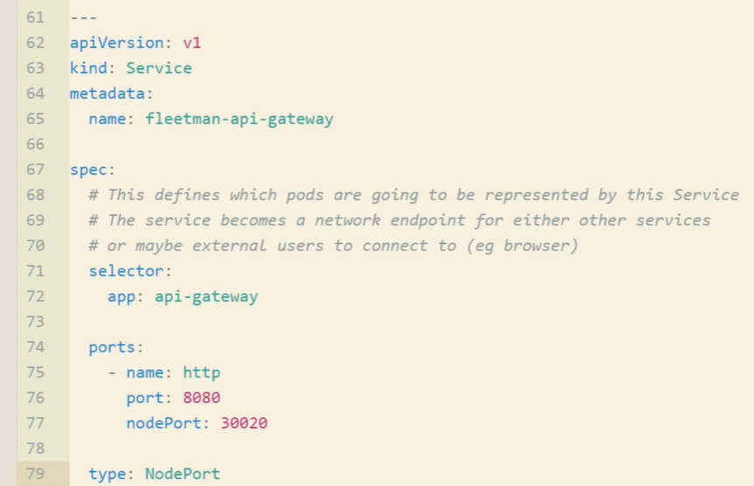

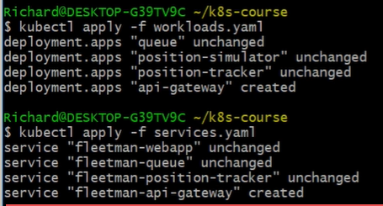

Kubectl get all

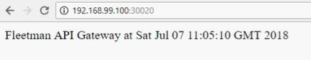

Change cluster ip and run the services.yaml again.

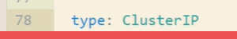

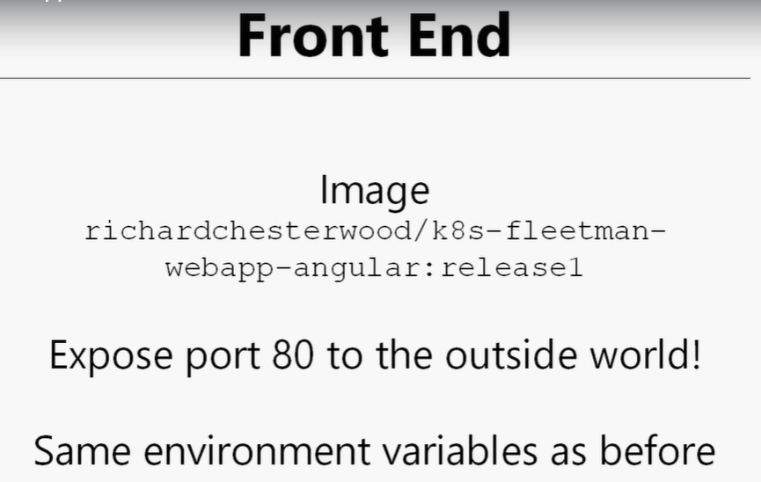

Add one more prod in the workloads.yaml file for the Front End.

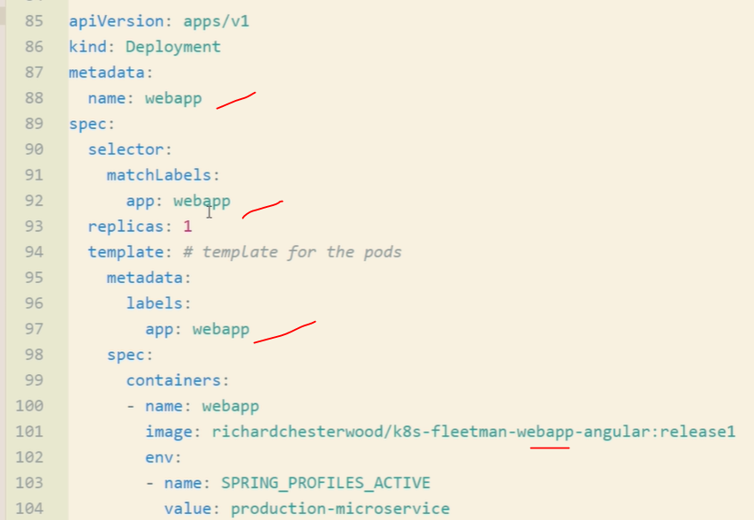

Add one more service in the services.yaml file for the Front End. Already we have it first service itself.

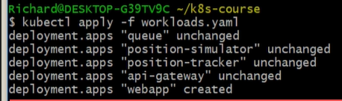

Kubectl get all==check the created contained running or not!

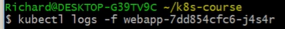

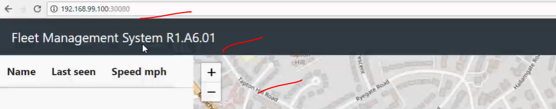



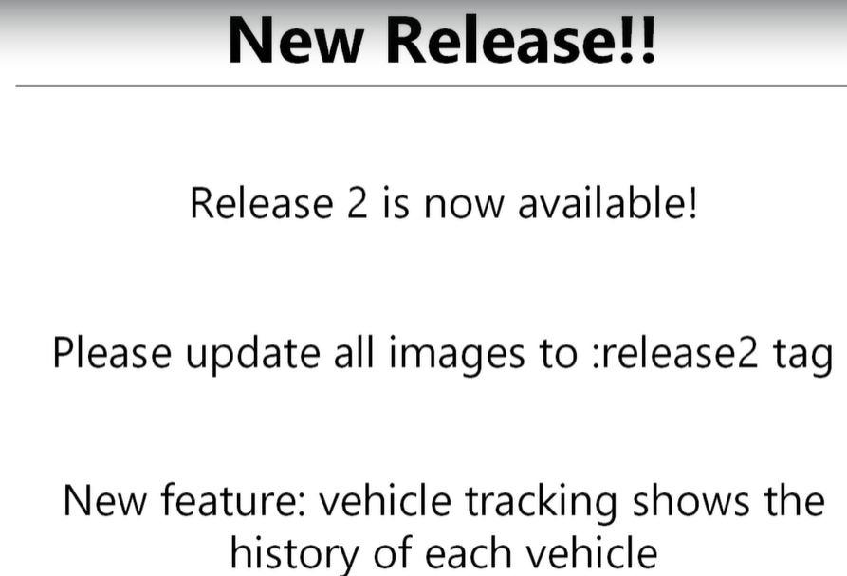

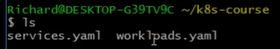

And update release name =release2 for all queue,position-simulator,position-tracker, api-gateway and webapp in the workloads.yaml file.

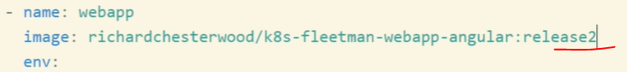

Save and run the kubectl apply -f .==dot means all files in the current directory.

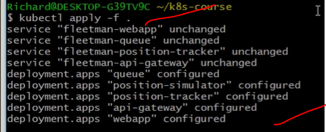

Kubectl get all

Some are terminated and new tags are crated now.

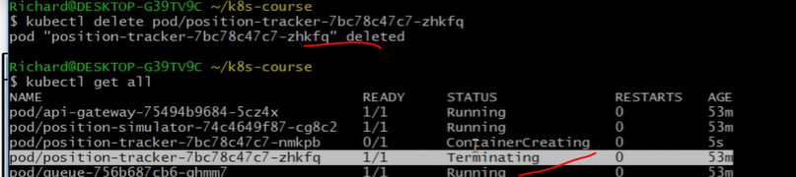



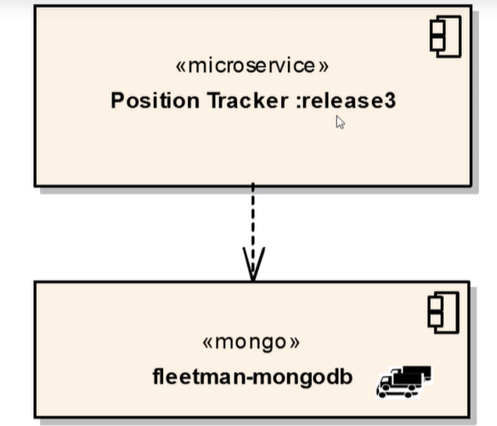

Create new mongo-stack.yaml prod file and deploy and run it.

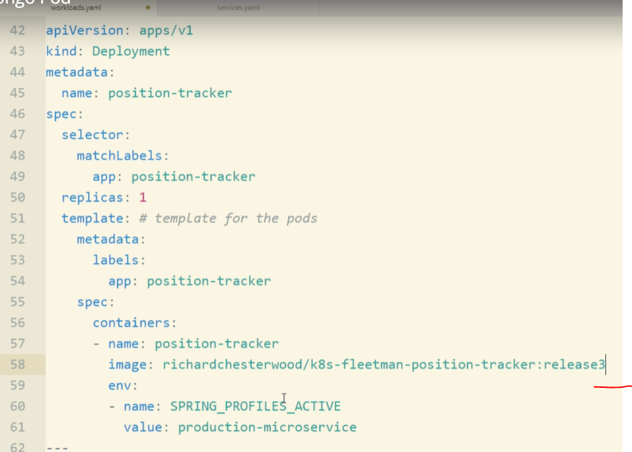

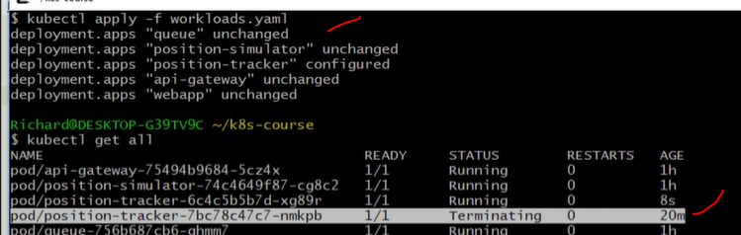

Mongodb:

<https://hub.docker.com/search?q=mongodb&type=image>

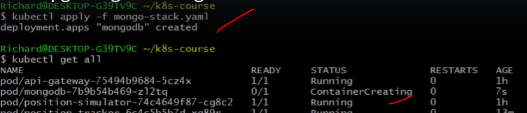



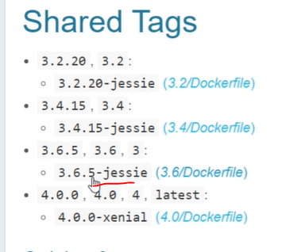

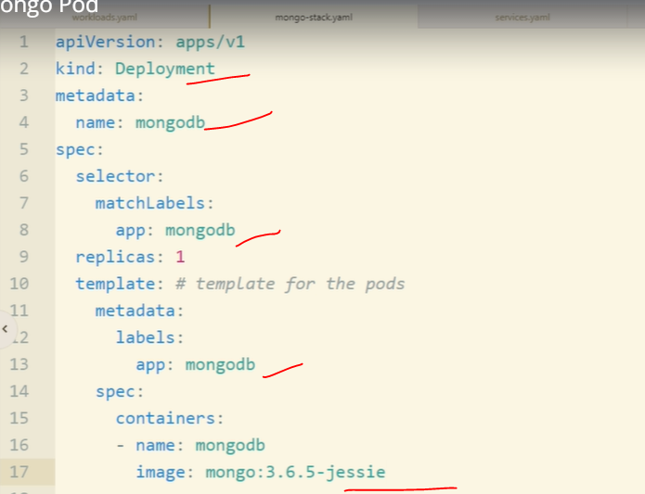

We can run prods and service same yaml file

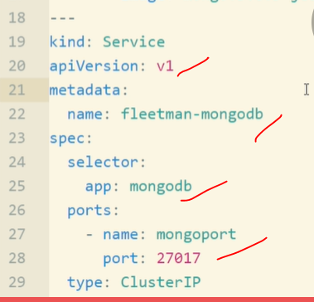

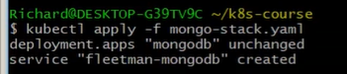

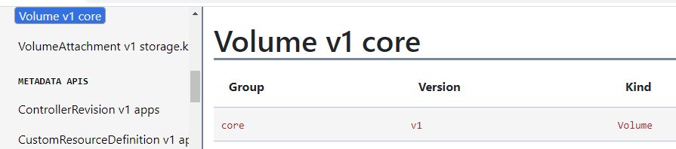

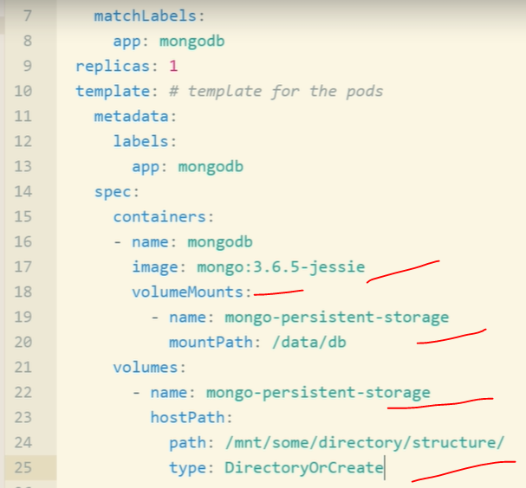

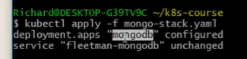

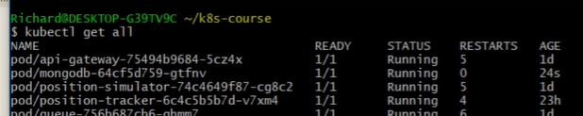

Dobbule click virtual box minikube and login into it.

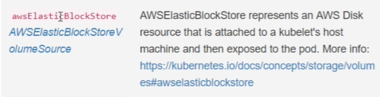

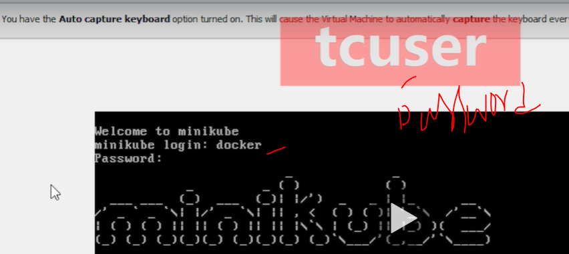

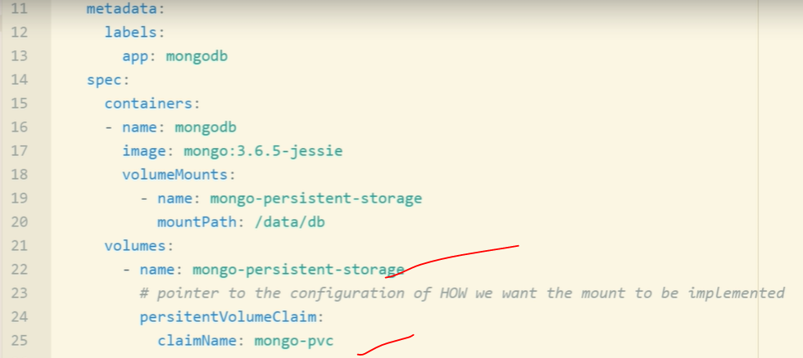

Create storage.yaml.

<https://kubernetes.io/docs/concepts/storage/#persistent-volumes/>

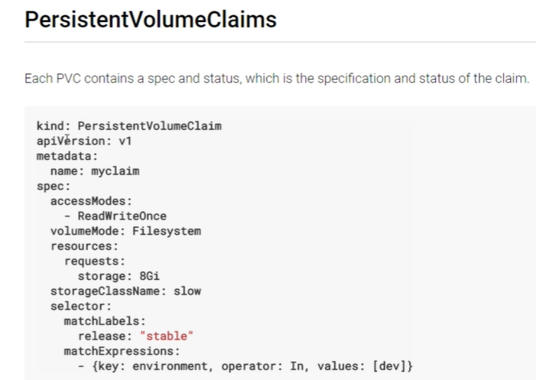

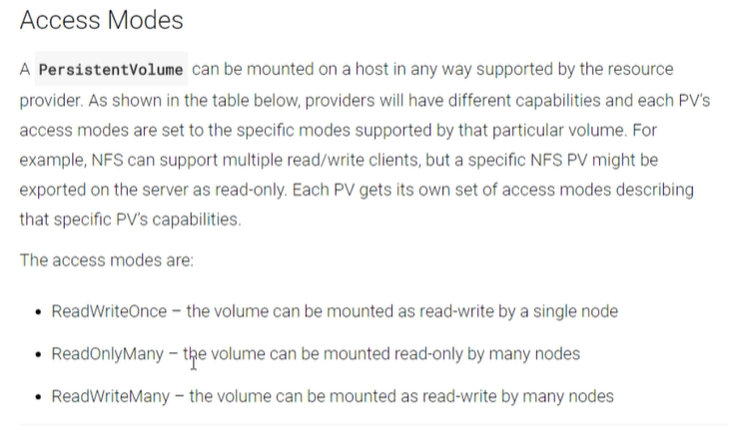

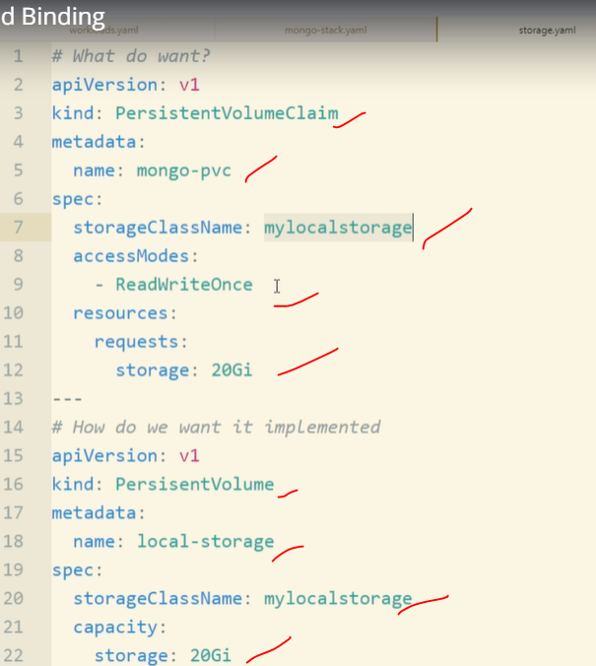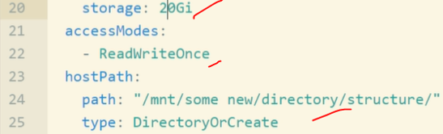

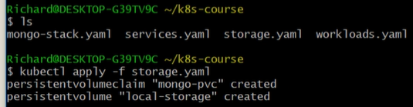



Persistency volume=pv

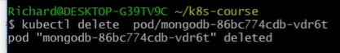



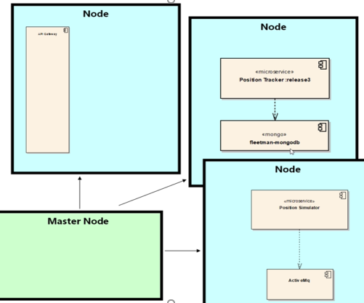

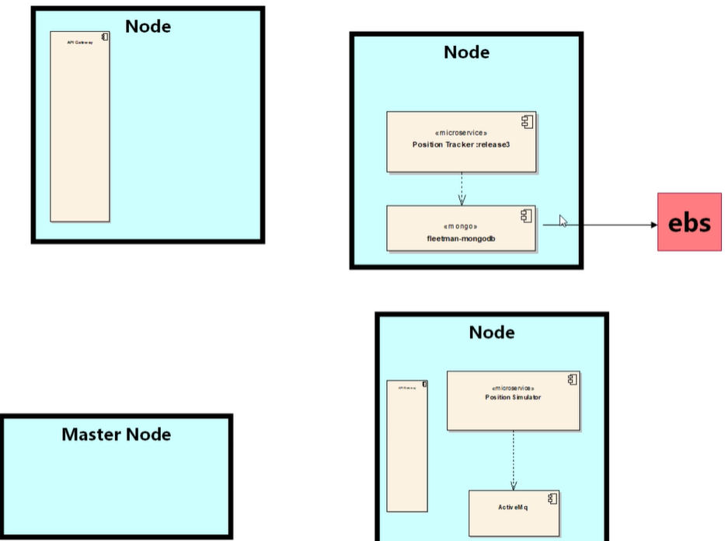



<https://github.com/madhureddy87/kops>

# kops - Kubernetes Operations

The easiest way to get a production grade Kubernetes cluster up and running.

## What is kops?

We like to think of it as kubectl for clusters.

kops helps you create, destroy, upgrade and maintain production-grade, highly available, Kubernetes clusters from the command line. AWS (Amazon Web Services) is currently officially supported, with GCE and OpenStack in beta support, and VMware vSphere in alpha, and other platforms planned.

Ssh install in the sngdrive editor:

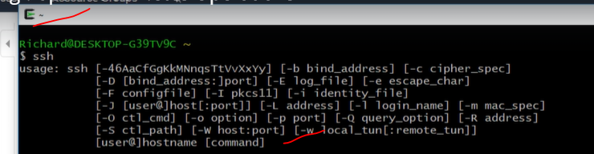

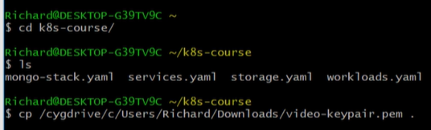

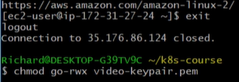



<https://github.com/madhureddy87/kops/blob/master/docs/install.md>

Linux:install

curl -Lo kops https://github.com/kubernetes/kops/releases/download/$(curl -s https://api.github.com/repos/kubernetes/kops/releases/latest | grep tag_name | cut -d '"' -f 4)/kops-linux-amd64

chmod +x ./kops

sudo mv ./kops /usr/local/bin/



Kops has installed

<https://github.com/madhureddy87/kops/blob/master/docs/install.md>

curl -Lo kubectl https://storage.googleapis.com/kubernetes-release/release/$(curl -s https://storage.googleapis.com/kubernetes-release/release/stable.txt)/bin/linux/amd64/kubectl

chmod +x ./kubectl

sudo mv ./kubectl /usr/local/bin/kubectl

kubectl version

<https://github.com/madhureddy87/kops/blob/master/docs/aws-china.md>

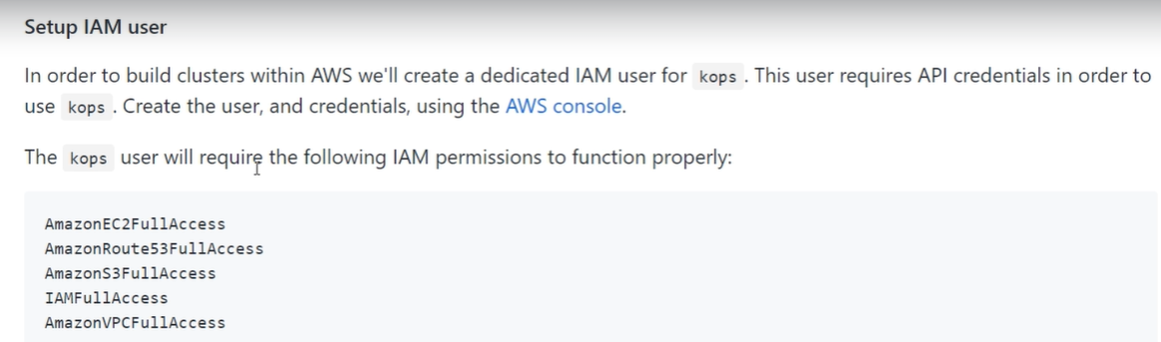

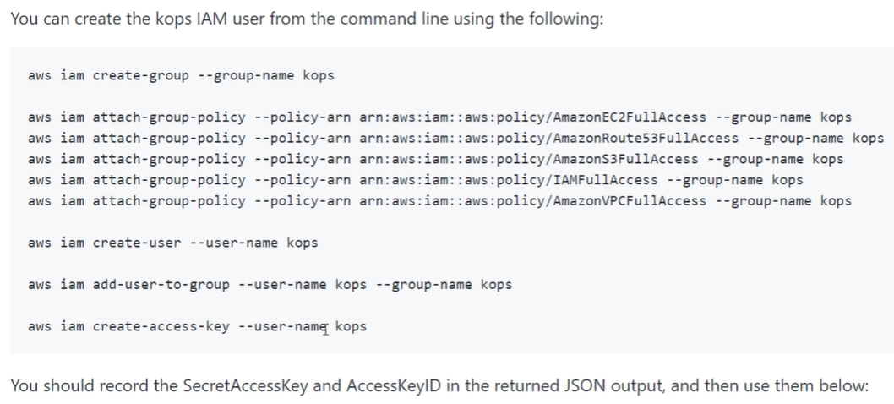

Go to IAM user and create new group(kops) and next step add below roles to kops group.

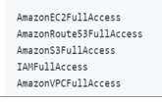

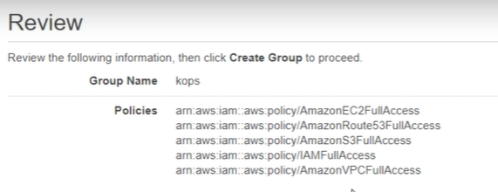

Create user->kops->programmatic access->add user to group->kops->review->create user.

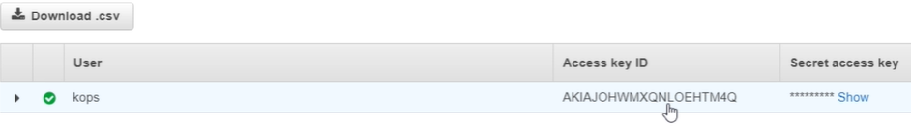

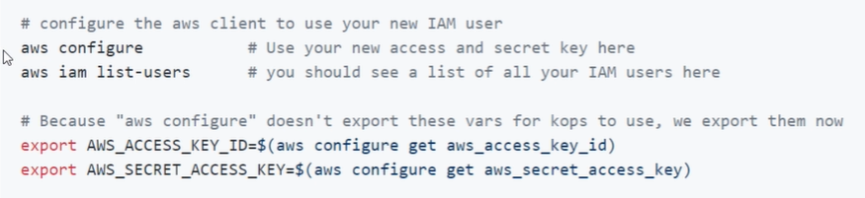

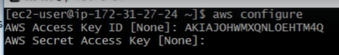



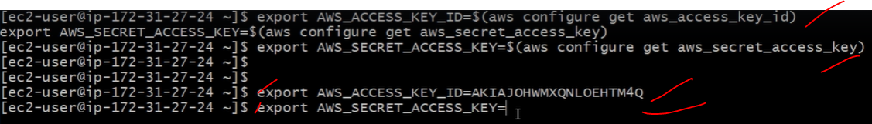

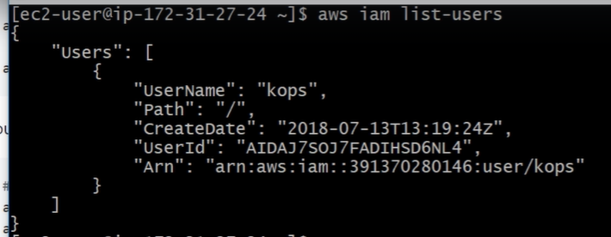

There's two solutions to this. You can either:

1. Use region us-east-1. This region will probably have the instance types that kops is using by default. It's usually fast enough wherever in the world you actually are.
2. Change the instance types you're using. Run the command:

kops get instancegroups

This will show the name of your master group (eg master-us-east-2c ). Now you can do:

kops edit ig <name of master group>

And you can change the instance type to one you can see in the pricing chart.

Then,

kops edit ig nodes

And do the same here.

CreATE A BUCKET USING BELOW COMMAND OR MANUALLY.

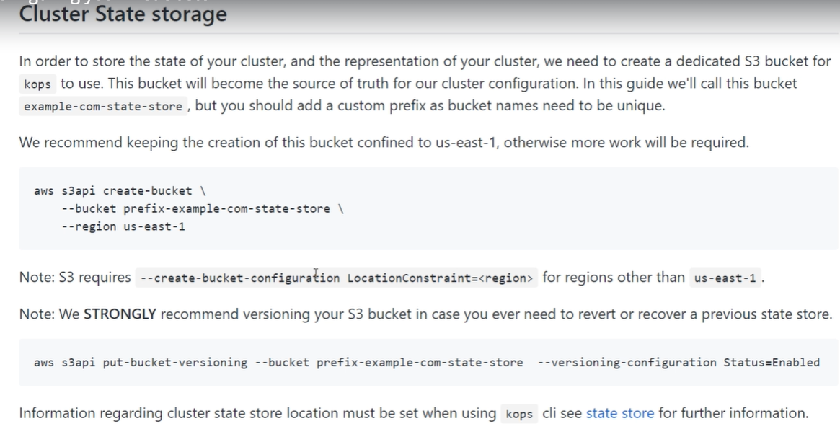

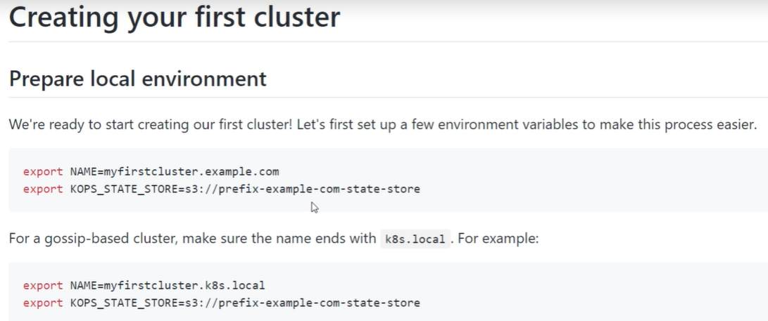

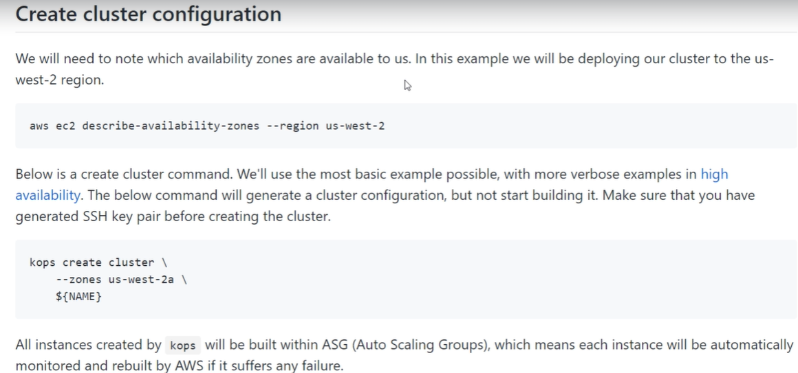



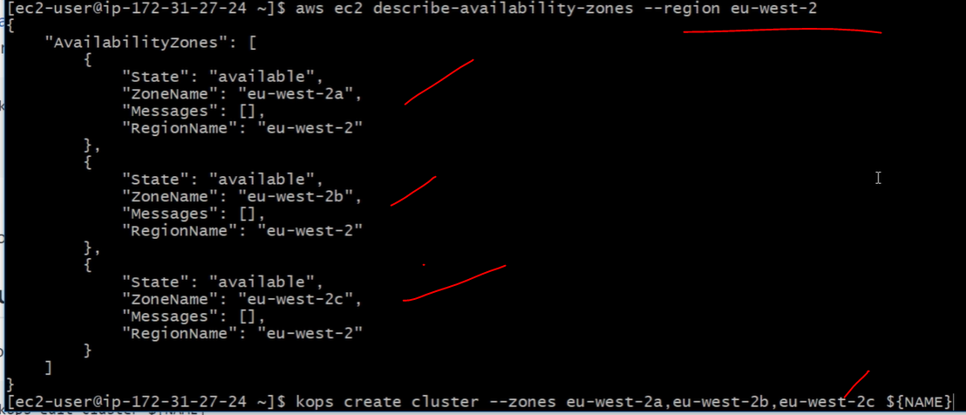

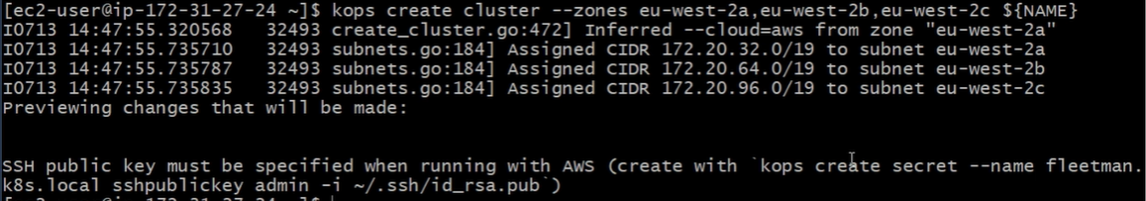





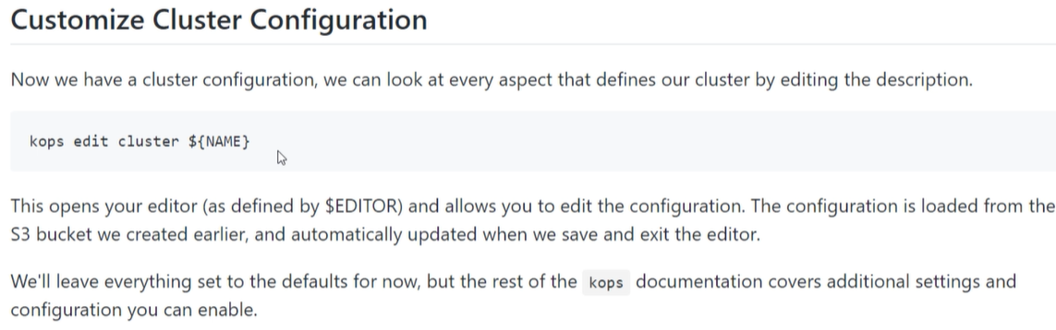

 IT’S LIKE A VI EDITOR.

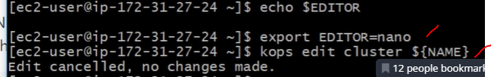  ig=instance group

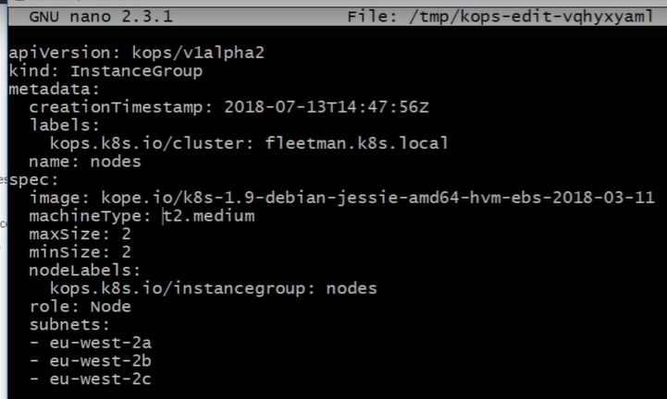  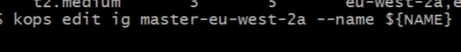

Master information in yaml format

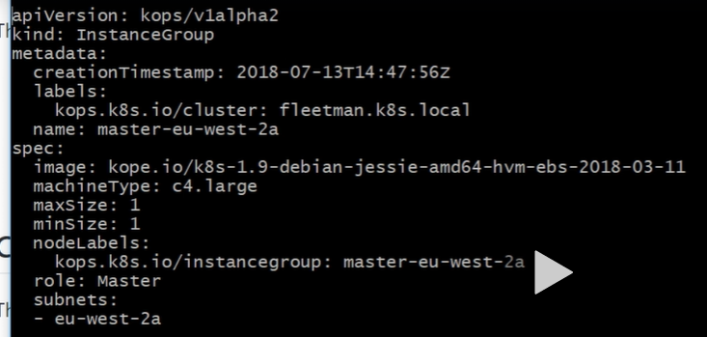

Starting the clusters:



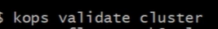



Check in the AWS, clusters are created now.

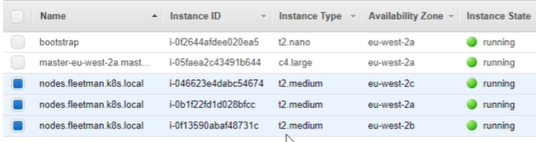

After some time clusters will up& running.

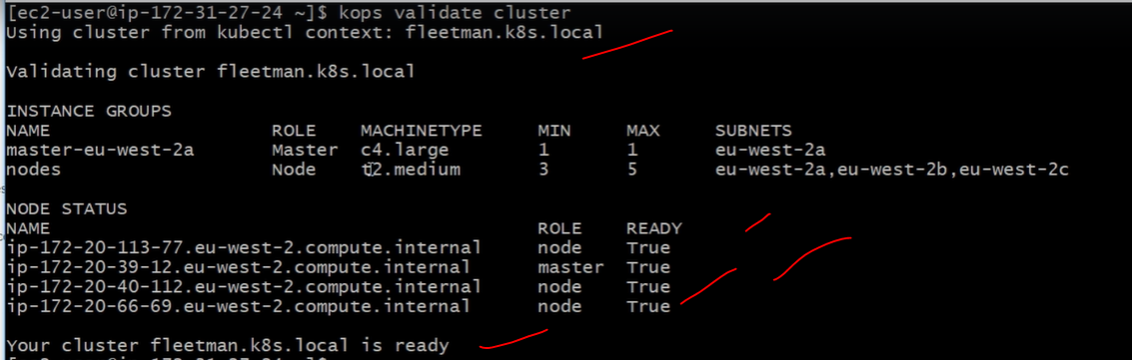

Kubectl get all==calling load balancer. Check in aws load balancer. And auto scale also configured automatically

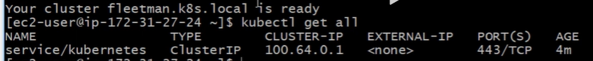

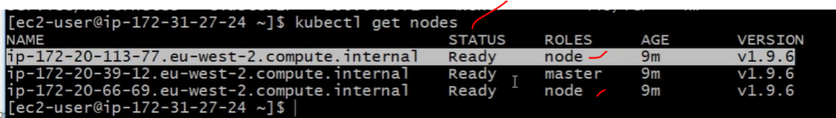

If any nodes are down automatically auto scale will crated default nodes.

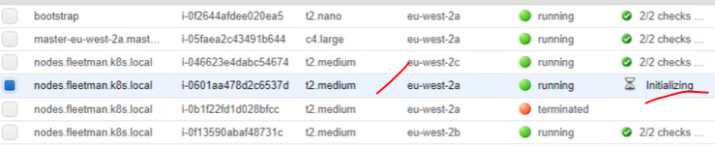

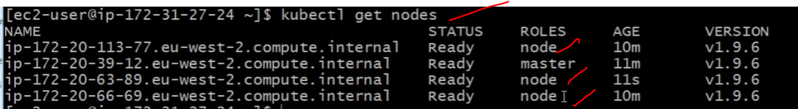

Kops validate cluster==it will provide the clusters status.

Kubectl get all

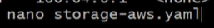

<https://kubernetes.io/docs/concepts/storage/storage-classes/#aws>

### **Provisioner**

Storage classes have a provisioner that determines what volume plugin is used for provisioning PVs. This field must be specified.

<https://kubernetes.io/docs/concepts/storage/storage-classes/#aws-ebs>

apiVersion: storage.k8s.io/v1

kind: StorageClass

metadata:

name: slow

provisioner: kubernetes.io/aws-ebs

parameters:

type: io1

iopsPerGB: "10"

fsType: ext4

# Amazon EBS Volume Types

Amazon EBS provides the following volume types, which differ in performance characteristics and price, so that you can tailor your storage performance and cost to the needs of your applications. The volumes types fall into two categories:

* SSD-backed volumes optimized for transactional workloads involving frequent read/write operations with small I/O size, where the dominant performance attribute is IOPS
* HDD-backed volumes optimized for large streaming workloads where throughput (measured in MiB/s) is a better performance measure than IOPS
* There are several factors that can affect the performance of EBS volumes, such as instance configuration, I/O characteristics, and workload demand. For more information about getting the most out of your EBS volumes, see [Amazon EBS Volume Performance on Linux Instances](https://docs.aws.amazon.com/AWSEC2/latest/UserGuide/EBSPerformance.html).
* The following table describes the use cases and performance characteristics for each volume type. The default volume type is General Purpose SSD (gp2).

|  |  |  |  |  |
| --- | --- | --- | --- | --- |
|  | **Solid-State Drives (SSD)** | | **Hard Disk Drives (HDD)** | |
| **Volume Type** | General Purpose SSD (gp2) | Provisioned IOPS SSD (io1) | Throughput Optimized HDD (st1) | Cold HDD (sc1) |
| **Description** | General purpose SSD volume that balances price and performance for a wide variety of workloads | Highest-performance SSD volume for mission-critical low-latency or high-throughput workloads | Low-cost HDD volume designed for frequently accessed, throughput-intensive workloads |  |

* <https://docs.aws.amazon.com/AWSEC2/latest/UserGuide/ebs-volume-types.html>

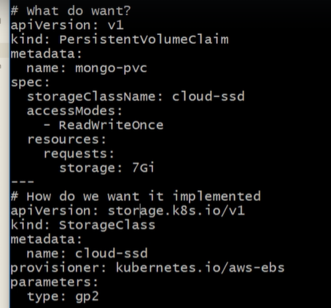

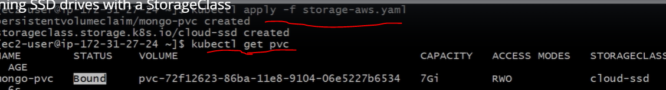



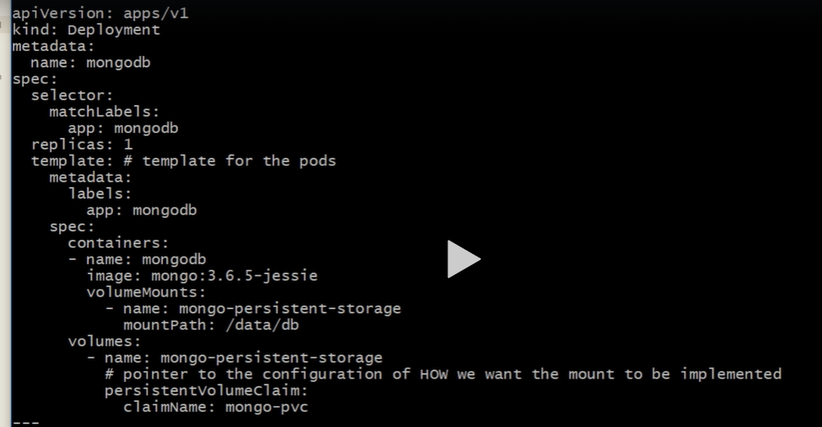

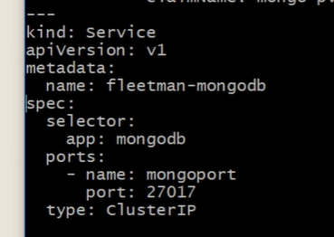



Kubectl get all

Kubectl describe mongodb…….

Kubectl logs -f prod/mongodb…..

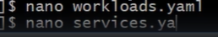

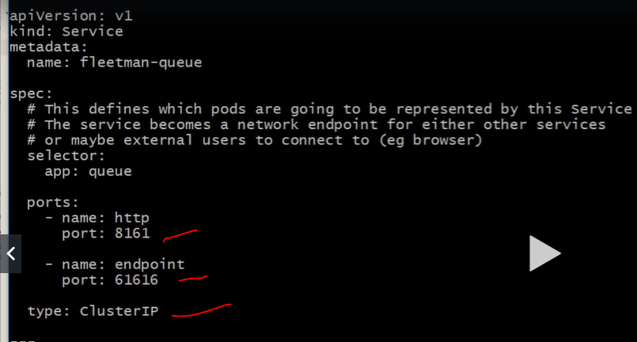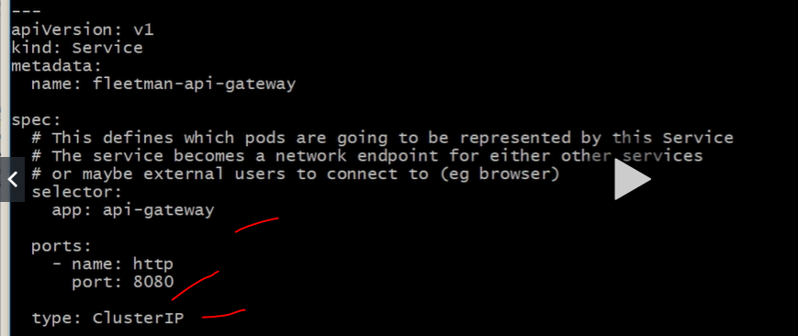

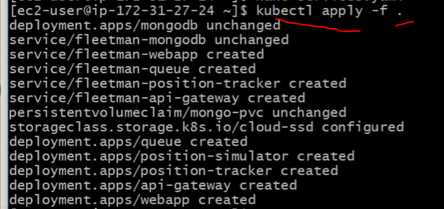

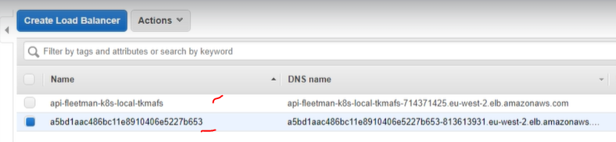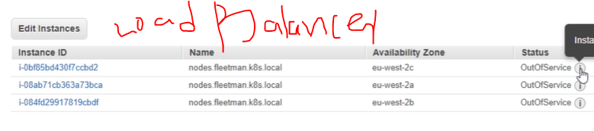

Check load balancer details and get DNS link as web link the web page working or not!

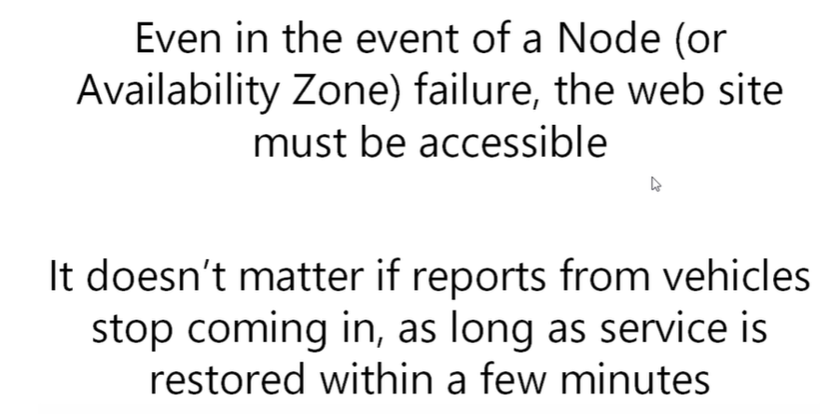

Kubectl get pods –list running pods in the docker

Kubectl get -owide will get more information about prods.

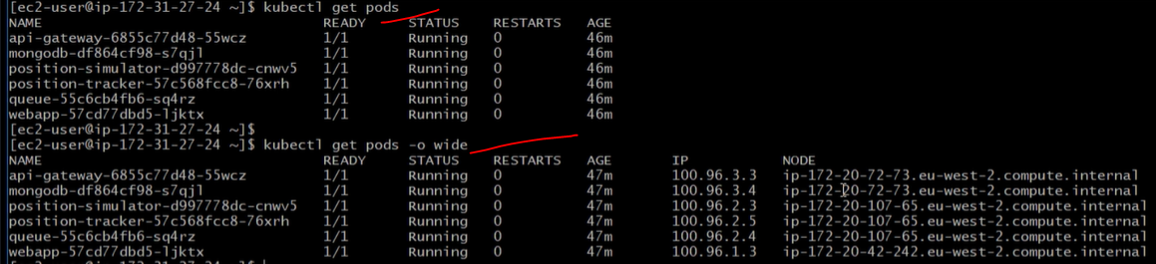

The above running instances aws instances.

Kubectl get nodes –it will disply the running nodes

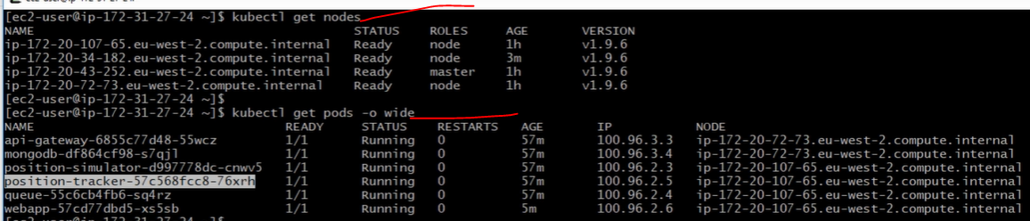

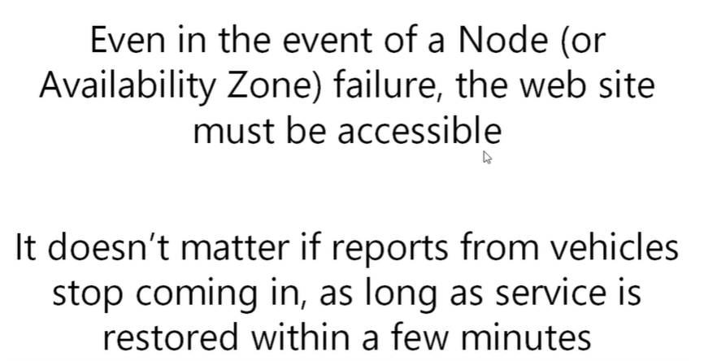

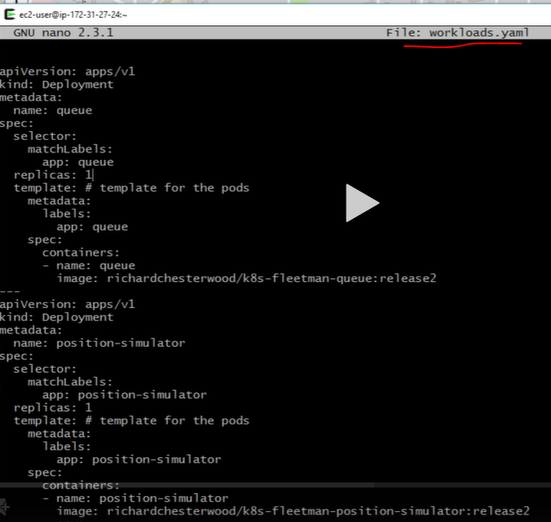

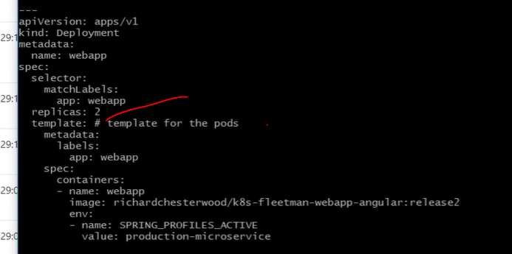

Kubectl apply -f . ==running all prods and services which are available in the correct directory..

Kubectl get pods

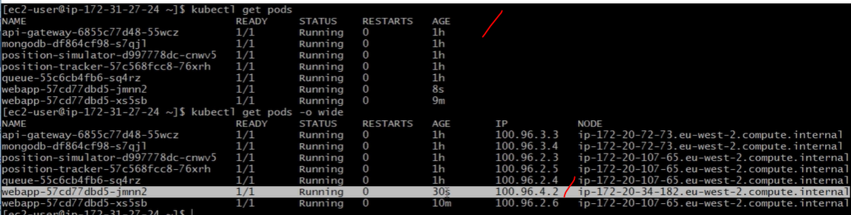

To delete all aws service then finally delete master node.



To restore last terminated nodes to tack the below and roll back it.

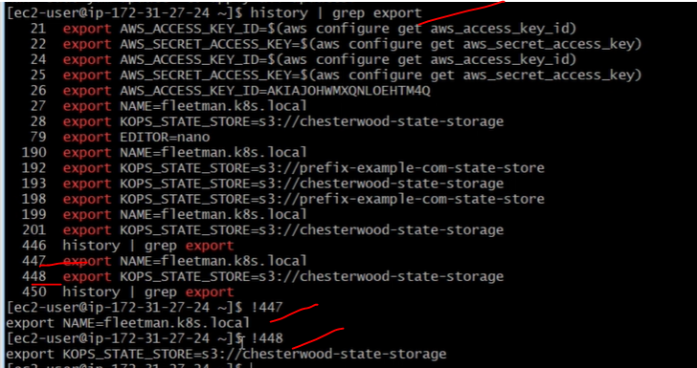





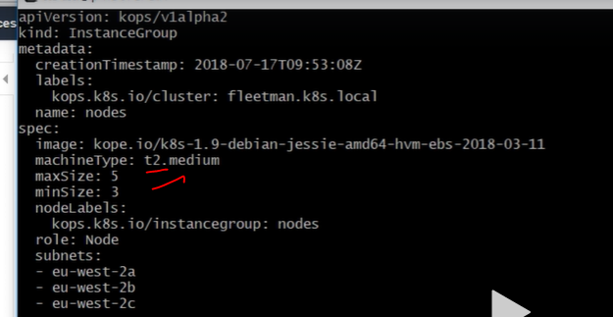

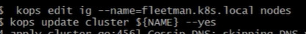

Kops validate cluster

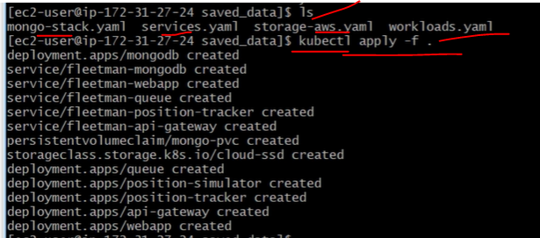

Kubectl get svc—list all running services.



Kubectl get po

Kubectl logs pods name

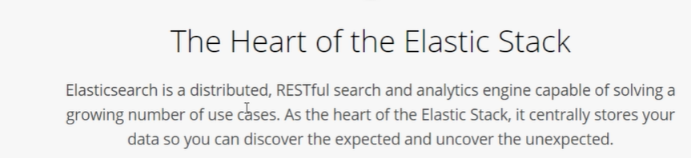

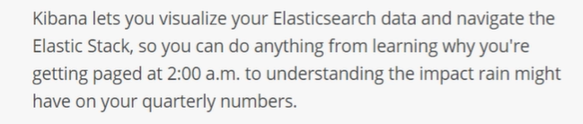

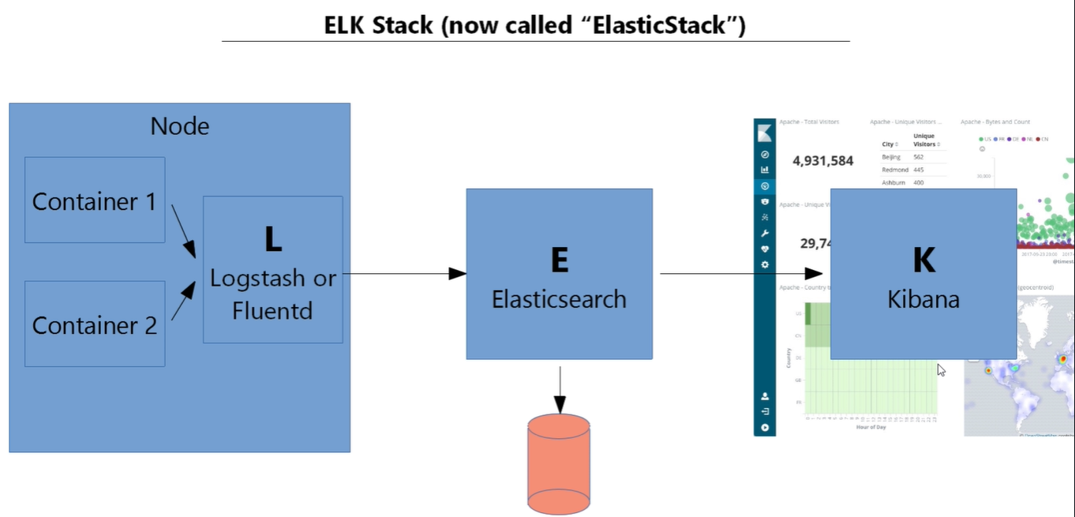

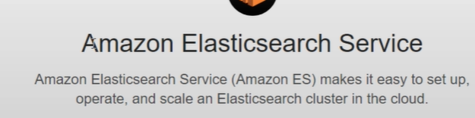

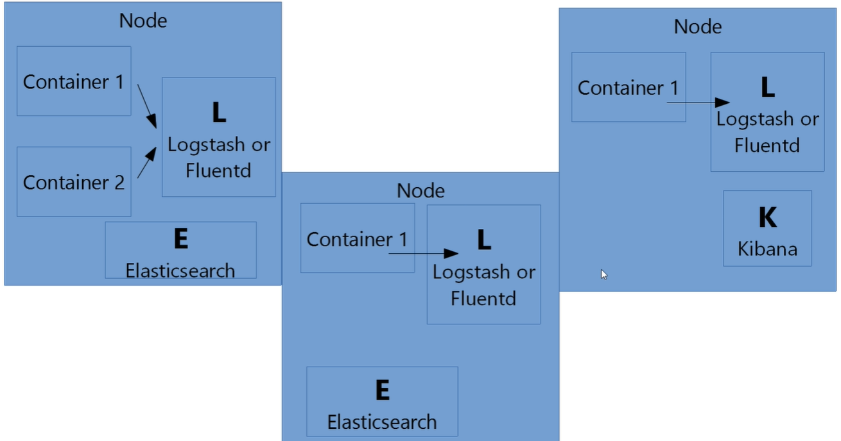



[kubernetes](https://github.com/madhureddy87/kubernetes)/[cluster](https://github.com/madhureddy87/kubernetes/tree/master/cluster)/[addons](https://github.com/madhureddy87/kubernetes/tree/master/cluster/addons)/**fluentd-elasticsearch**/

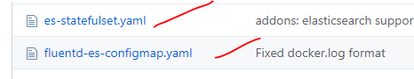

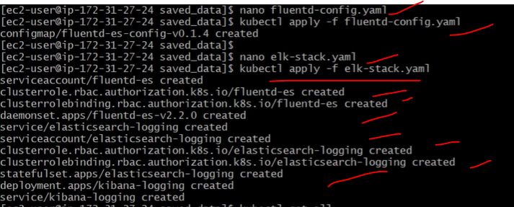

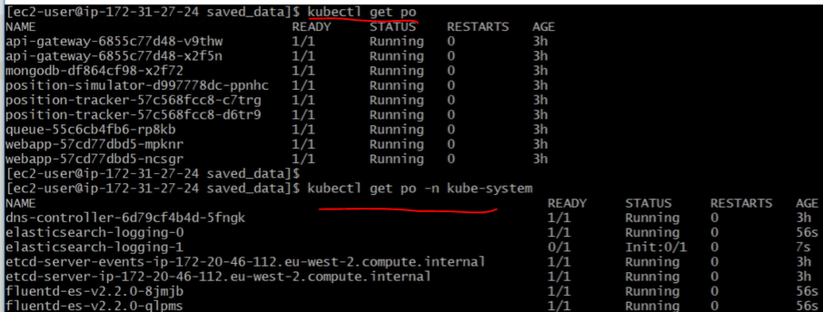

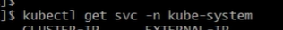

Check the all service and load balancer are running or now. Then login with load balancer with port number for the Kibana web-site.

By using Elastic search, we are going to configure within Kibana for the monitoring purposes.

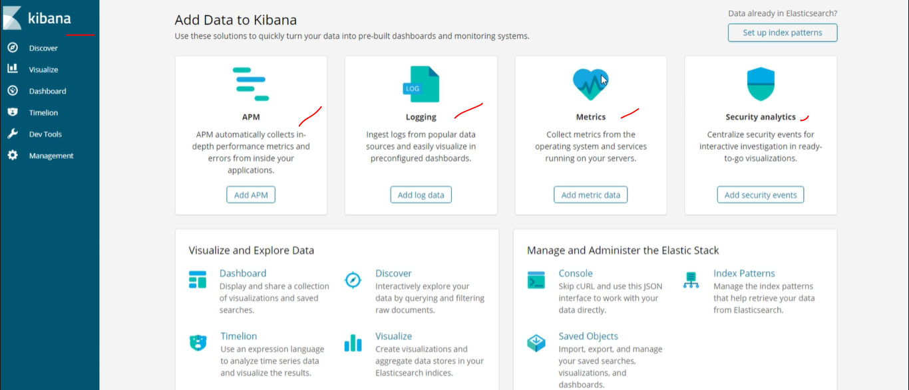

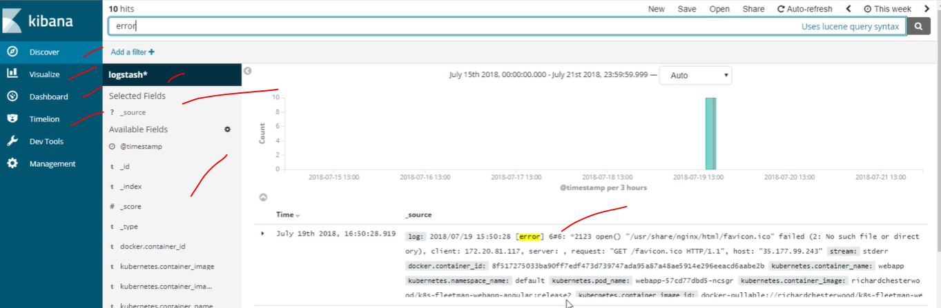

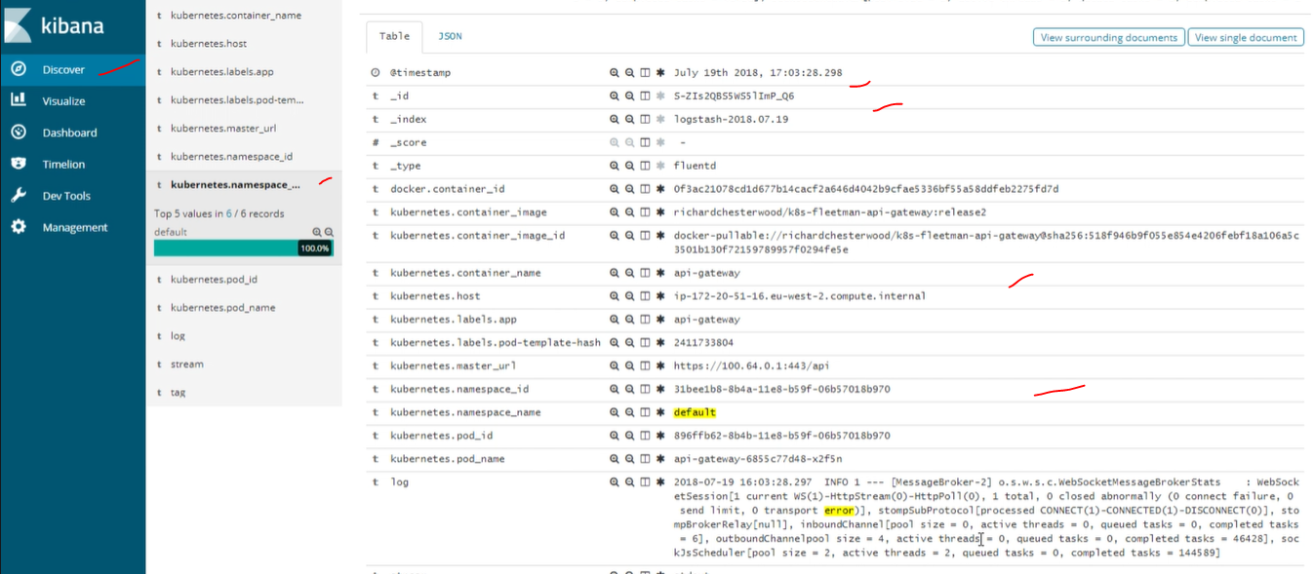

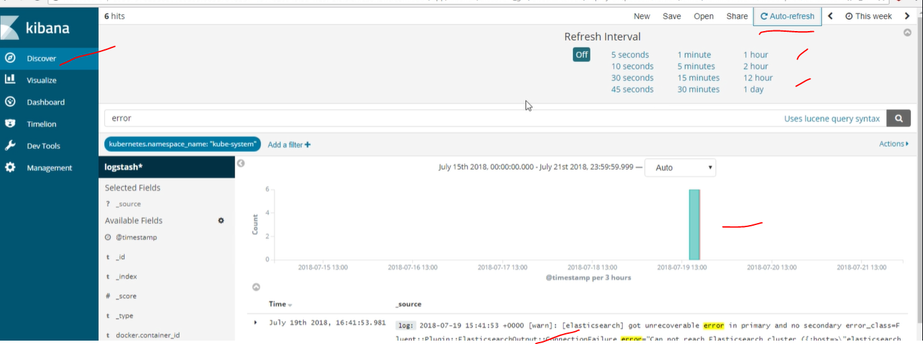

Kubectl get po

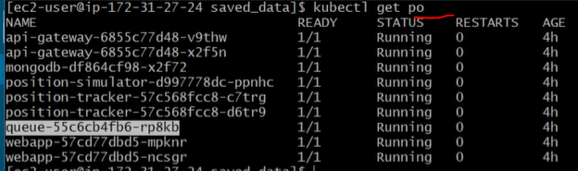

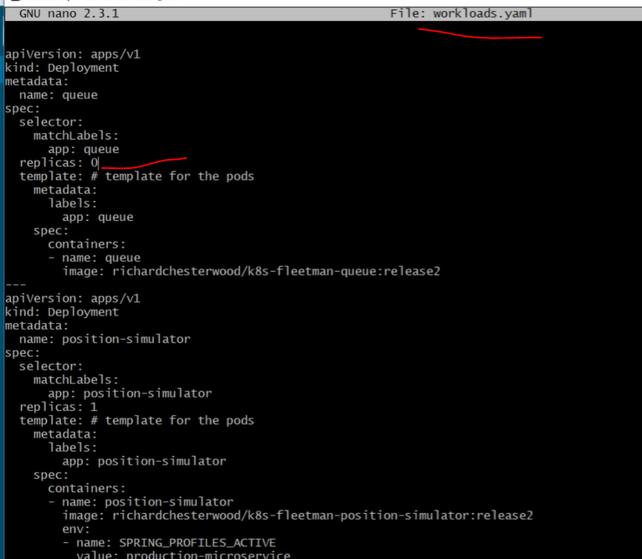

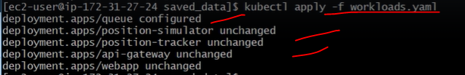

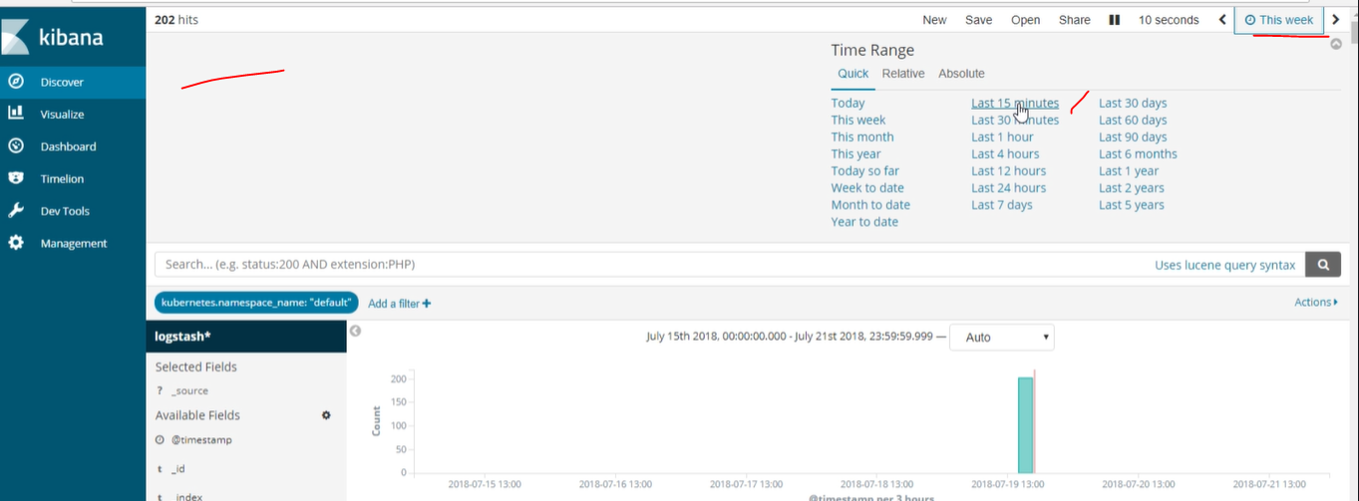

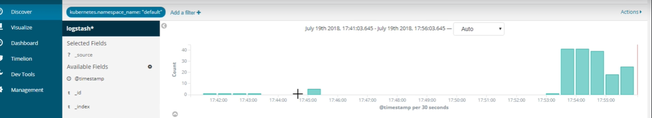

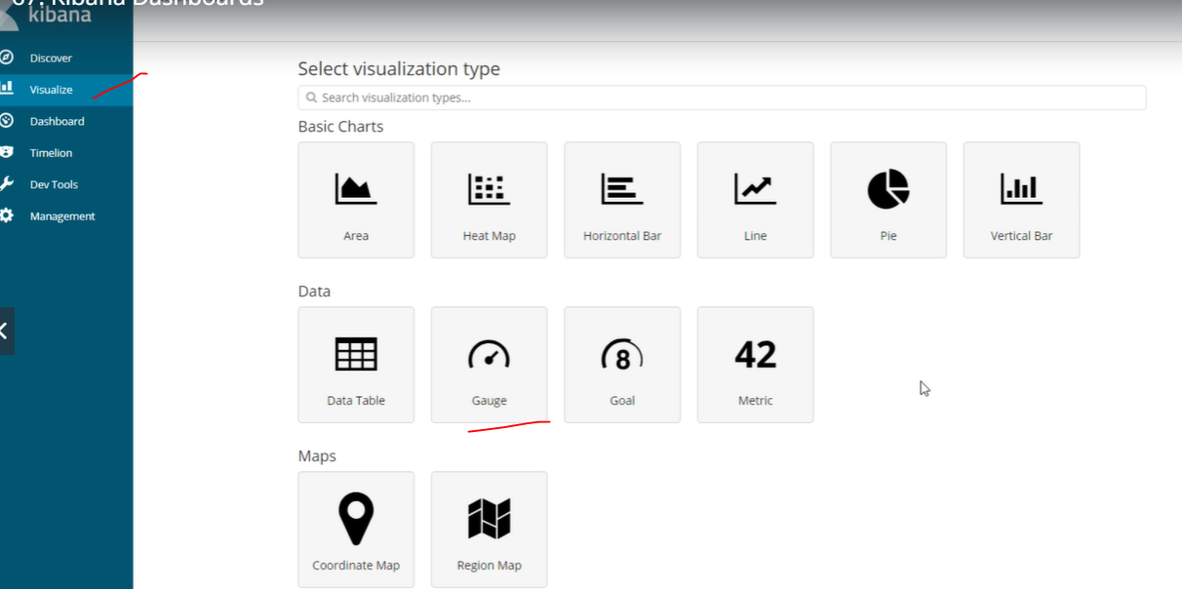

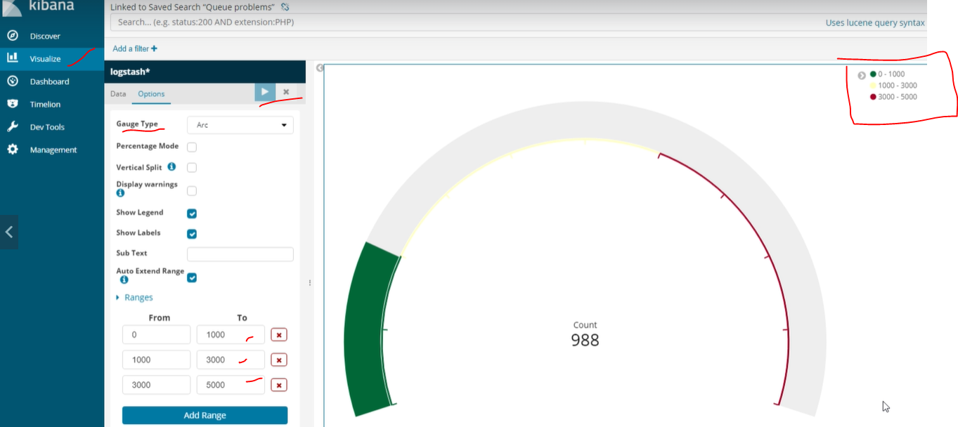

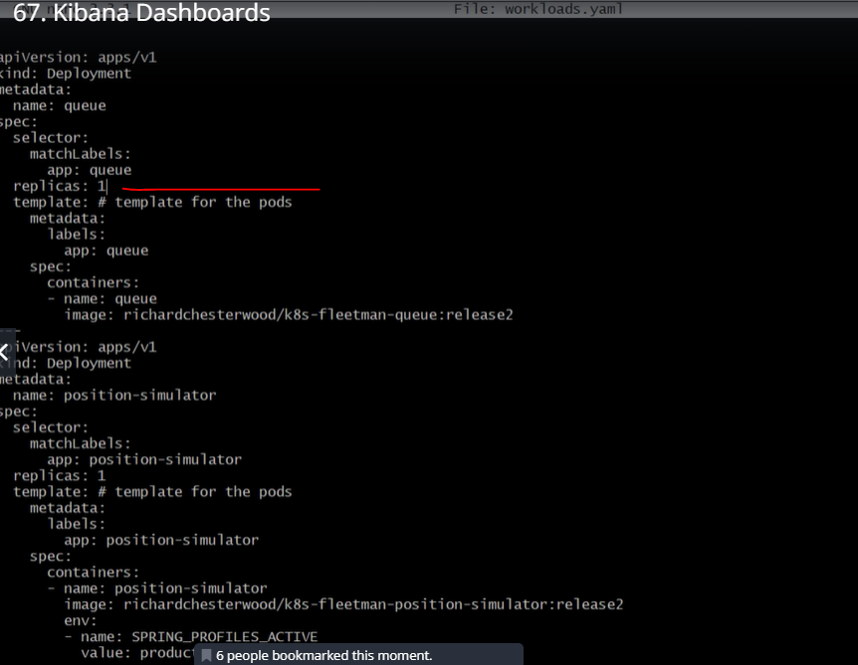

Kubectl apply -f workload.yaml

Check now last-minute changes at running status of kubernetes.

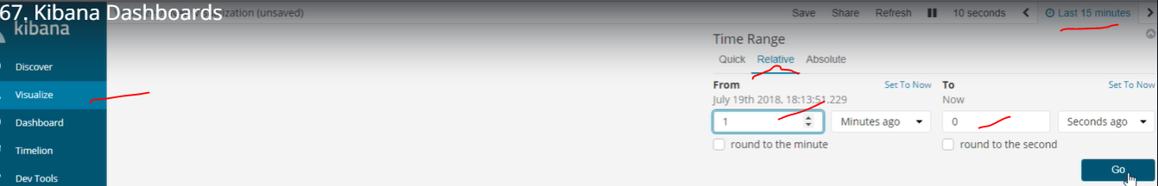

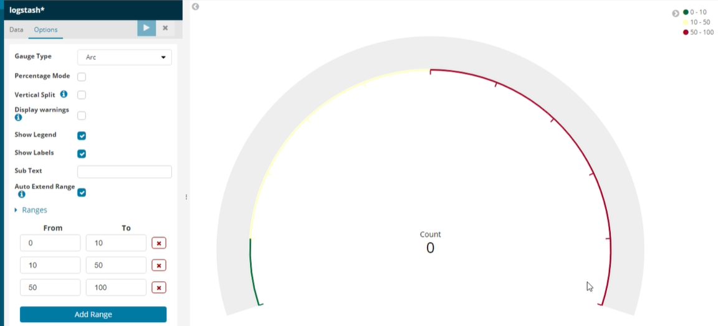

Again change replicas=0 in the workload.yaml file then check the graph now.

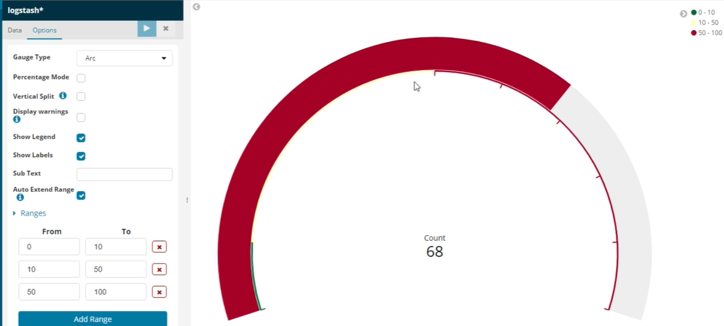

We can setup a dashboards a visualize in to multiple graph to monitor.

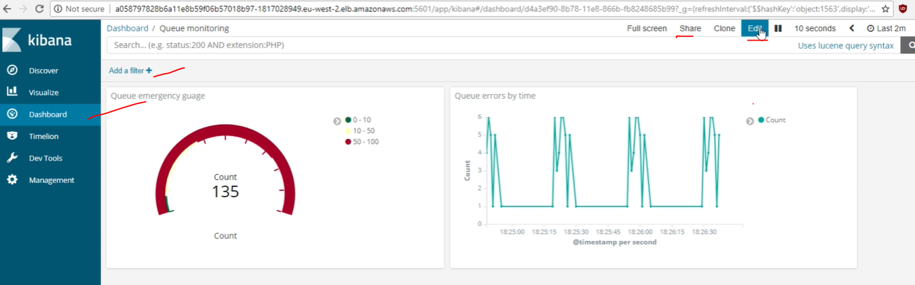

Again, change replicas=1 in the workload.yaml file then check the graph now.it will give us full clear pitcher of prods and services.



We are monitoring in the AWS CONSOL for each and every instance.select particular node/instance check in the monitoring tab.

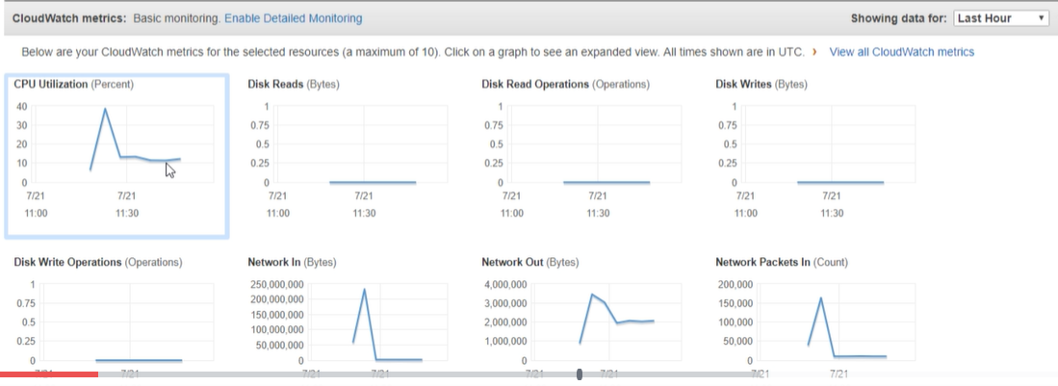

And we can also use opensource tools for the monitoring purpose. Prometheus and Grafana Labs is one of monitoring tools.

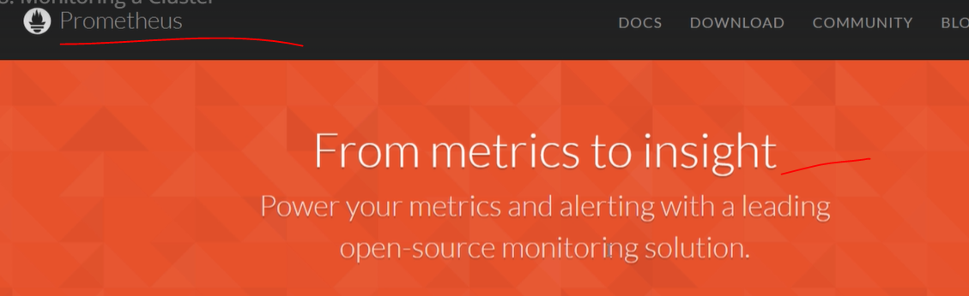

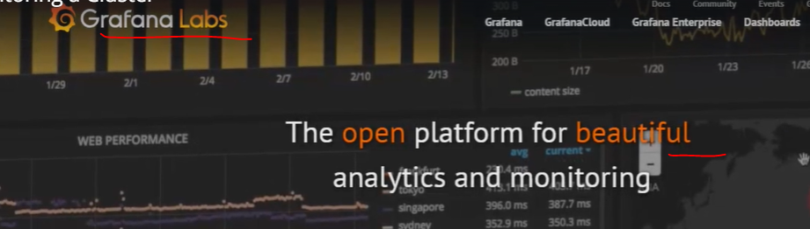

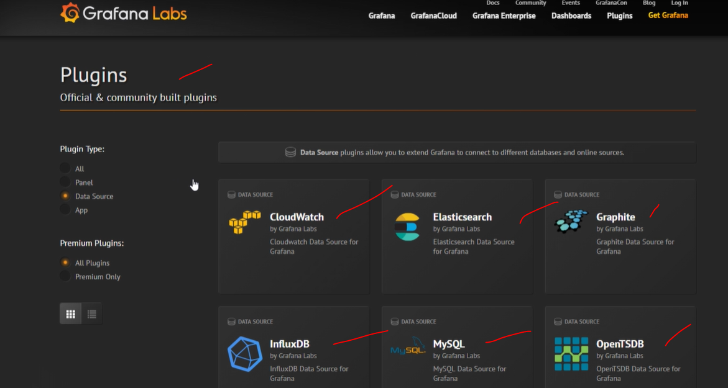



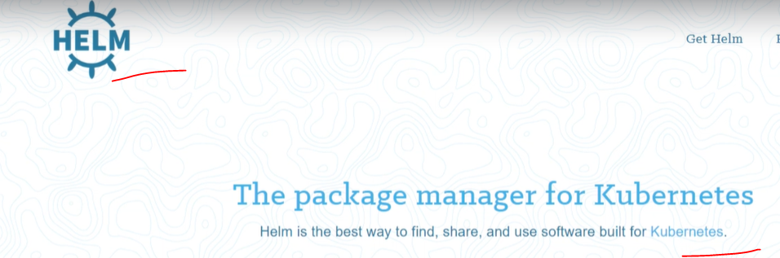

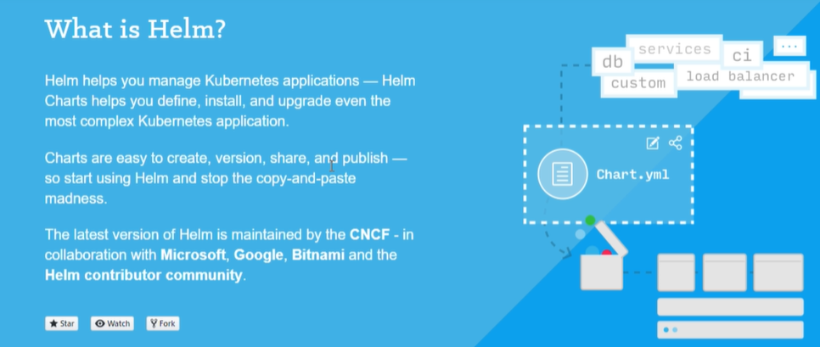

<https://github.com/helm/helm/releases/tag/v3.1.1>

<https://get.helm.sh/helm-v3.1.1-linux-386.tar.gz>



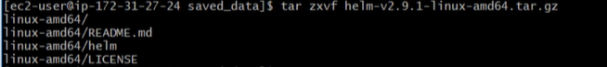

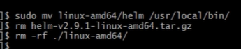

Now helm has been installed now just type helm will help information about helm.

helm version

helm init

kubectl get po -m kube-system ---it should be show in the list tiller-deploy container for helm.

